ROLLS-ROYCE | MEDIA INFORMATION
A MAGNIFICENT 20-YEAR RELATIONSHIP:
ROLLS-ROYCE AND CHICHESTER FESTIVAL THEATRE

11 December 2023, Goodwood, West Sussex
- Rolls-Royce marks 20 years as a Platinum Sponsor of the internationally renowned Chichester Festival Theatre
- Relationship dates from the official opening of the Home of Rolls-Royce at Goodwood in 2003
- Long-term support for a leading local institution, underlining Rolls-Royce’s place at the heart of life in Chichester
- Reflects shared values of celebrating creativity and community, and inspiring and delighting patrons

“This year we mark 20 years of hand-crafting motor cars at Goodwood, and throughout that time, we’ve enjoyed a wonderful relationship with our friends at Chichester Festival Theatre. This acclaimed venue, only a couple of miles from the Home of Rolls-Royce, is one of our home city’s crown jewels. As one of just a handful of Platinum Sponsors, it’s our privilege and pleasure to support its wonderful work, both on its fabled stage and in the local community. Together, we represent two great Chichester institutions, with a shared commitment to championing creativity, community engagement and practising our respective arts at the very highest level.”
Andrew Ball, Head of Corporate Relations and Heritage, Rolls-Royce Motor Cars
Rolls-Royce Motor Cars celebrates 20 years as a leading supporter of the nearby Chichester Festival Theatre – a continuous relationship that dates from the start of motor car production at the Home of Rolls-Royce at Goodwood in 2003.
Rolls-Royce is one of a select group of Platinum Sponsors at the world-renowned venue, which lies just a couple of miles from the marque’s Goodwood site.
Chichester Festival Theatre was founded in 1962, financed by donations from local businesses and individuals in an early example of what today would be called crowdfunding. The main auditorium seats up to 1,300 people, with a ‘thrust stage’ design equally suited to musicals and epic drama. A Grade II* Listed building, it underwent a comprehensive restoration in 2014.
The opening night was on 3 July 1962, under the artistic directorship of the legendary actor, Sir Laurence Olivier, and the company became the nucleus of his new National Theatre company. In the six decades since, many productions including musicals, new plays and classic revivals have transferred successfully to London’s West End and toured both nationally and internationally. Its flagship Festival Season runs from April to October and attracts almost a quarter of a million theatregoers annually; the Theatre also runs an extensive programme of workshops and events for the local community.
As a Platinum Sponsor, Rolls-Royce Motor Cars is an important contributor to the Theatre’s artistic and outreach work, promoting the creativity and excellence that are central to the marque’s own values. The relationship also underlines the deep roots Rolls-Royce has established in the local community since it chose Chichester as the location for its new home in the early 2000s.
In 2007, the partnership was recognised with a Sustainability Award from Arts & Business South East. The following year, Rolls-Royce’s beautiful, landscaped grounds provided a glorious setting for Chichester Festival Youth Theatre’s open-air promenade show, Toad of Toad Hall.
Kathy Bourne, Executive Director of Chichester Festival Theatre, says: “Rolls-Royce is a leading light of Chichester’s business community and we’ve hugely valued the company’s generous sponsorship over the past 20 years, ever since the Goodwood-based manufacturing plant was first established. We share with Rolls-Royce a strong commitment to our local community and an international reputation for excellence, flying the flag for British expertise worldwide. We offer them our warmest congratulations on their 20th anniversary and our thanks for their ongoing support.”
- ENDS -

EDITORS’ NOTES
Rolls-Royce Motor Cars is a true luxury house, creating the world’s most recognised, revered and desirable handcrafted Bespoke products for its international clientele.
The company employs more than 2,500 people at the Home of Rolls-Royce at Goodwood, West Sussex. This comprises both its global headquarters and Centre of Luxury Manufacturing Excellence – the only place in the world where Rolls-Royce motor cars are designed, engineered and meticulously built by hand. Its continuous investment in its facilities, products and people has resulted in a series of ‘record years’ for global sales, peaking in 2022 with over 6,000 motor cars sold worldwide.
Rolls-Royce Motor Cars is a wholly owned subsidiary of the BMW Group and is a completely separate, unrelated company from Rolls-Royce plc, the manufacturer of aircraft engines and propulsion systems.

FURTHER INFORMATION
You can find all our press releases and press kits, as well as a wide selection of high resolution, downloadable photographs and video footage at our media website, PressClub.
You can also follow marque on social media: LinkedIn; YouTube; X (Twitter); Instagram; and Facebook.

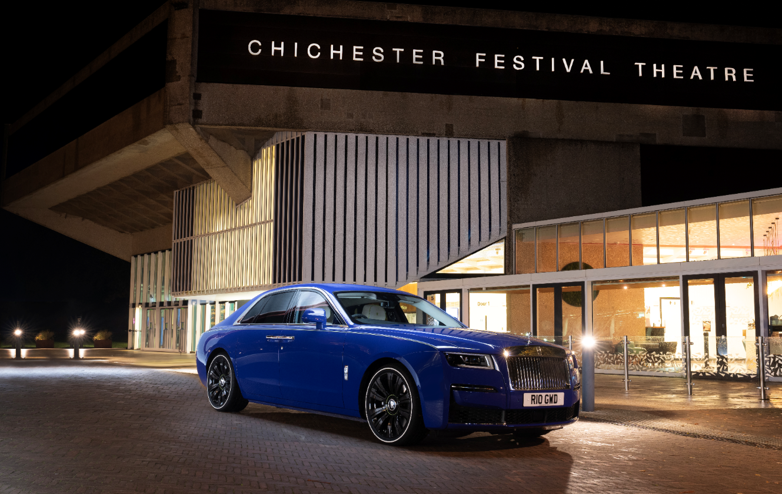
Ghost: NEDCcorr (combined) CO2 emission: 359 g/km; Fuel consumption: 15.8 mpg / 18.0 l/100km. WLTP (combined) CO2 emission: 359 g/km; Fuel consumption: 17.9 mpg / 15.8 l/100km.

Further information: https://bit.ly/3XtQW7q

CONTACTS | GOODWOOD
Director of Global Communications  Emma Begley  +44 (0) 1243 384060 / Email | Head of Global Product Communications  Georgina Cox  +44 (0) 7815 370878 / Email
Head of Corporate Relations  Andrew Ball  +44 (0) 7815 244064 / Email | Global Product PR Manager  Katie Sherman  +44 (0) 7815 244896 / Email
United Kingdom and Ireland
Isabel Matthews
+44 (0) 7815 245127 / Email

CONTACTS | GLOBAL
The Americas  Gerry Spahn  +1 201 930 8308 / Email | China  Ou Sun  +86 186 0059 0675 / Email
Central/Eastern Europe and Central Asia  Frank Tiemann  +49 160 9697 5807 / Email | Central and Western Europe  Ruth Hilse  +49 (0) 89 382 60064 / Email
Asia Pacific  Hal Serudin  +65 8161 2843 / Email | Japan and Korea  Yuki Imamura  +81 90 5216 1957 / Email
Middle East and Africa
Rami Joudi
+971 56 171 7883 / Email

