ROLLS-ROYCE │ **BESPOKE INSIGHTS**

**THE MAHLANGU PHANTOM**

**CANVAS:** PHANTOM

**MEDIUM:** PAINT (ARTIST DR. ESTHER MAHLANGU)

PRESS RELEASE:13 February 2020

**CELEBRATED ARTIST DR. ESTHER MAHLANGU PAINTS UNIQUE ARTWORK FOR ROLLS-ROYCE PHANTOM GALLERY**

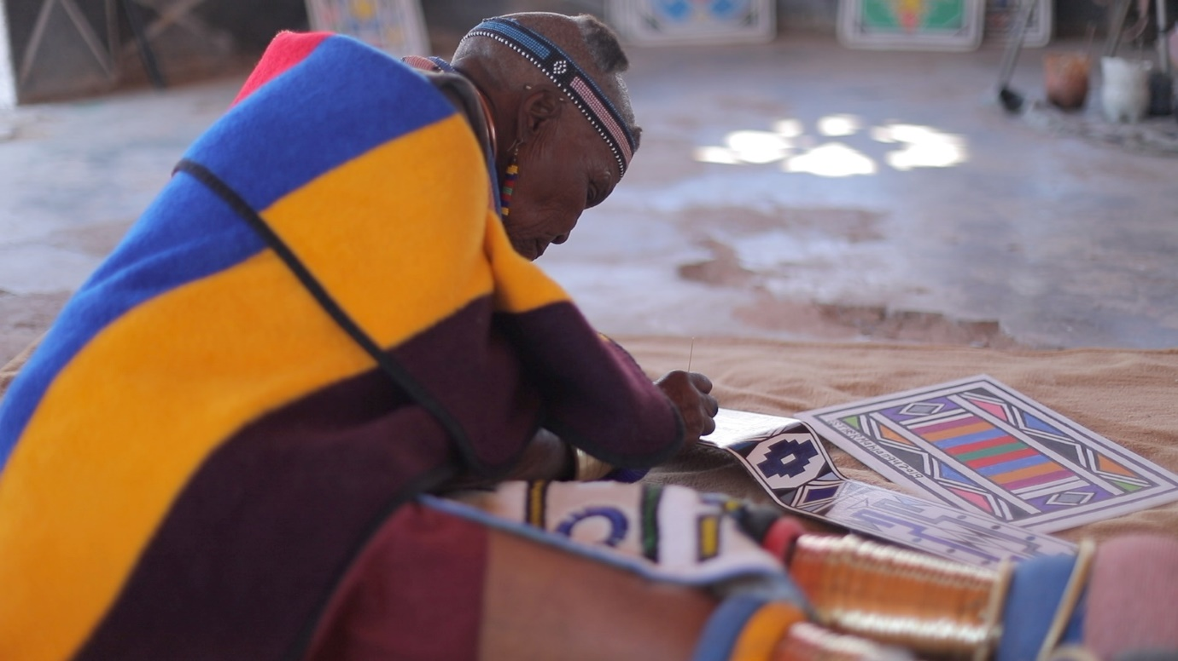

Rolls-Royce’s flagship, Phantom, has within it, an interior space which spans the dash facia and which is enclosed by a sheet of glass. This unprecedented space is called the Gallery. It provides clients of the marque the unique opportunity to commission and display, within their Phantom, highly personal works of art. Positioned front and centre, the Gallery becomes a focal point for Phantom’s interior.

Dr. Esther Mahlangu, the globally celebrated South African artist, has been commissioned by a South African patron of Rolls-Royce to create a unique work of art for the Gallery of a one-of-a-kind Rolls-Royce Phantom. Dr. Mahlangu, the visual artist from the Ndebele region and respected South African cultural ambassador, becomes the first artist to create an artwork in this way. This unique motor car is named, ‘The Mahlangu Phantom’ in the artist’s honour.

César Habib, Regional Director, Rolls-Royce Motor Cars Middle East and Africa, commented, “I am delighted to unveil ‘The Mahlangu Phantom’, a striking expression of contemporary African art. The Gallery is a unique environment for patrons of our marque to express personal and often highly creative artworks and we are indeed honoured to showcase Dr. Mahlangu’s work in this Phantom’s serene interior.”

Considered, in South Africa, as a national treasure, Dr. Mahlangu has devoted her life to sharing her cultural heritage through vibrant geometric abstract paintings and murals inspired by the Ndebele ethnic group. The 84-year-old is one of Africa’s most revered living artists and her works can be found in many important museums, corporate and private collections around the world.

With the goal of preserving her cultural heritage, Mahlangu founded an art school at her home in the Mpumalanga province where she mentors young artists in the traditional style of Ndebele design. A portion of the proceeds from the sale of ‘The Mahlangu Phantom’ will be donated to the school and will be used to support a retrospective exhibition that will narrate her fascinating life story and celebrate her invaluable contribution to contemporary African art.

“Dr. Mahlangu has been painting the bright, geometric, abstract artworks for which she has become so globally acclaimed since she was 10 years old. We are excited to have been appointed to curate this important Retrospective exhibition that will celebrate and honour Dr. Mahlangu and her important contribution to contemporary African art,” says Craig Mark, Director of The Melrose Gallery, Dr. Mahlangu’s global representative.

In celebration of this unique commission, Rolls-Royce has produced an insightful film to showcase Esther Mahlangu’s work and cultural heritage.

- Ends -

**Further information:**

You can find all our press releases and press kits, as well as a wide selection of high resolution, downloadable photographs and video footage at our media website, [PressClub](http://www.press.rolls-roycemotorcars.com/).

**Contacts:**

**Director of Global Communications**Richard Carter +44 (0) 1243 384060 [richard.carter@rolls-roycemotorcars.com](mailto:richard.carter@rolls-roycemotorcars.com)

**Head of Global Lifestyle Communications**Emma Rickett +44 (0) 1243 384061 [emma.rickett@rolls-roycemotorcars.com](mailto:emma.rickett@rolls-roycemotorcars.com)