ROLLS-ROYCE | MEDIA INFORMATION

ROLLS-ROYCE REVEALS NEW ghost EXTENDED
24 September 2020, Goodwood, West Sussex Under Embargo 00.01 BST

#rollsroyceghost

- The most rear legroom in a four-seat sedan with the exception of Phantom Extended
- 170mm longer than Ghost, offering greater space and legroom for rear-seat occupants
- Provides enhanced rear comfort with no compromise to driving dynamics
- Presents own identity within minimalist Post-Opulent design philosophy

New Ghost is the result of in-depth dialogue with Rolls-Royce’s diverse and global customer base. Many of them asked the marque to create a motor car that provides the indulgence of enhanced rear space within the interior suite with no compromise to driving dynamics. Ghost Extended answers this customer demand by creating a product that augments both their business and lifestyle requirements.”
Torsten Müller-Ötvös, Chief Executive Officer, Rolls-Royce Motor Cars

INTRODUCTION

Rolls-Royce Motor Cars announces new Ghost Extended, offering the indulgence of enhanced rear seating space with no compromise to Ghost’s driving dynamics. Ghost Extended is the product of an exhaustive process of consultation with a new generation of Rolls-Royce clients. This global, highly dynamic group of entrepreneurs expressed a desire for a chauffeur-driven business tool for the week that can transform into a serenely comfortable and dynamic self-driven saloon at the weekend. Ghost Extended is the response. First customer deliveries will be made in the fourth quarter of 2020.

DESIGN
Ghost Extended offers 170mm more space than Ghost, providing more rear legroom than any four-seat sedan with the exception of a Rolls-Royce Phantom Extended. Customer centricity has informed every step of the development process. A key learning was that Ghost Extended customers wanted no compromise to Ghost’s pure, minimalist design. The marque’s designers worked to cloak the extra length by only extending the rear door and body around the rear door apertures, preserving the lines of the car.

TECHNOLOGY
Rear Suite Serenity
A suite of enhancements to the rear of the cabin reflects Ghost Extended’s flexibility. For the first time, a reclining Serenity Seat can be selected, offering a new dimension of rear seat comfort akin to a business jet cabin environment.
The rear cabin also provides the perfect environment to transition from business to leisure. To enhance this, a Champagne fridge is provided between the rear seats and has been developed with exacting attention to the needs of the Rolls-Royce client. To achieve this, the marque’s engineers consulted with a Master Sommelier. They learned that the optimum serving temperatures of non-vintage Champagne is around six degrees centigrade and vintage Champagnes is around 11 degrees centigrade. To that end, the refrigerator operates two cooling modes, chilling to six degrees and 11 degrees.

Technology Without Obtrusion

Ghost is the most technologically advanced Rolls-Royce ever created. For Ghost Extended’s entrepreneurial customers, access to WiFi and cutting-edge infotainment systems is essential for use during the business day. However, technological functions have been deployed with care to reflect customer demand for a serene environment, free from unnecessary distractions.
The commitment to delivering a pure, detoxifying space extends to the air within the cabin. To deliver this, Ghost is equipped with a new Micro-Environment Purification System (MEPS). This technology enhances existing air filtration systems through software and hardware. Highly sensitive Impurity Detection Sensors detect ambient air quality, automatically activating fresh air intakes into Recirculation Mode. If unacceptable levels of airborne contaminants are detected, the air is passed through a nanofleece filter that is capable of removing nearly all ultra-fine particles within the cabin in less than two minutes.
A suite of technologies enhances the driving experience in urban and country settings. This includes laser headlights with more than 600m of illuminated range and key safety enhancements including vision assist with day and night-time wildlife and pedestrian warning; alertness assistant; a four-camera system with panoramic view, all round-visibility and helicopter view; active cruise control; collision warning; cross traffic warning; lane departure and lane change warning. An industry-leading 7x3 high definition head-up display and self-park ensures absolute effortlessness whatever the driving conditions.
ENGINEERING
All-Aluminium Spaceframe and New V12 Engine
Ghost Extended is built on the Architecture of Luxury, Rolls-Royce’s proprietary all-aluminium spaceframe that underpins every new Rolls-Royce model. The marque's hallmark Magic Carpet Ride is delivered by a new Planar Suspension System, the result of more than 10 years' exhaustive testing and refinement by specialist engineers. Featuring continuously variable, electronically controlled shock absorbers, self-levelling high-volume air strut assemblies and a world-first upper wishbone damper; this technology has never been previously applied to a production motor car. Ghost Extended also benefits from all-wheel drive and all-wheel steering for the first time.
Power is provided by a 6.75-litre twin turbocharged engine developed exclusively for Ghost. It produces 571PS and 850Nm of torque. The requirement for silence when travelling is answered through 100kg of acoustic damping materials incorporated into the chassis, bodywork and tyres, delivering exhilarating performance without disturbing the serenity within.

MATERIALS AND METHODS
Simplicity Through Complexity
The pursuit of design simplicity requires highly complex engineering and craft techniques. For example, sophisticated bodywork forms are only achievable through advanced generative design and 3D printing. This is the first time this technology has been incorporated within a component production facility and combined with Rolls-Royce’s craft and engineering competencies.
For Ghost Extended, beam-melted metal components are welded to the body-in-white, while parts made by multi-jet fusion and selective laser sintering are individually fitted at the Home of Rolls-Royce.
More traditional craft is given a contemporary expression through the introduction of two new wood finishes, developed especially for Ghost. Obsidian Ayous is inspired by the rich palette of colours found in igneous rocks, while Dark Amber has veins of fine aluminium particles running through the wood. Both are available in open-pore finish, allowing the tactility of the material to fully express itself.

ENDS
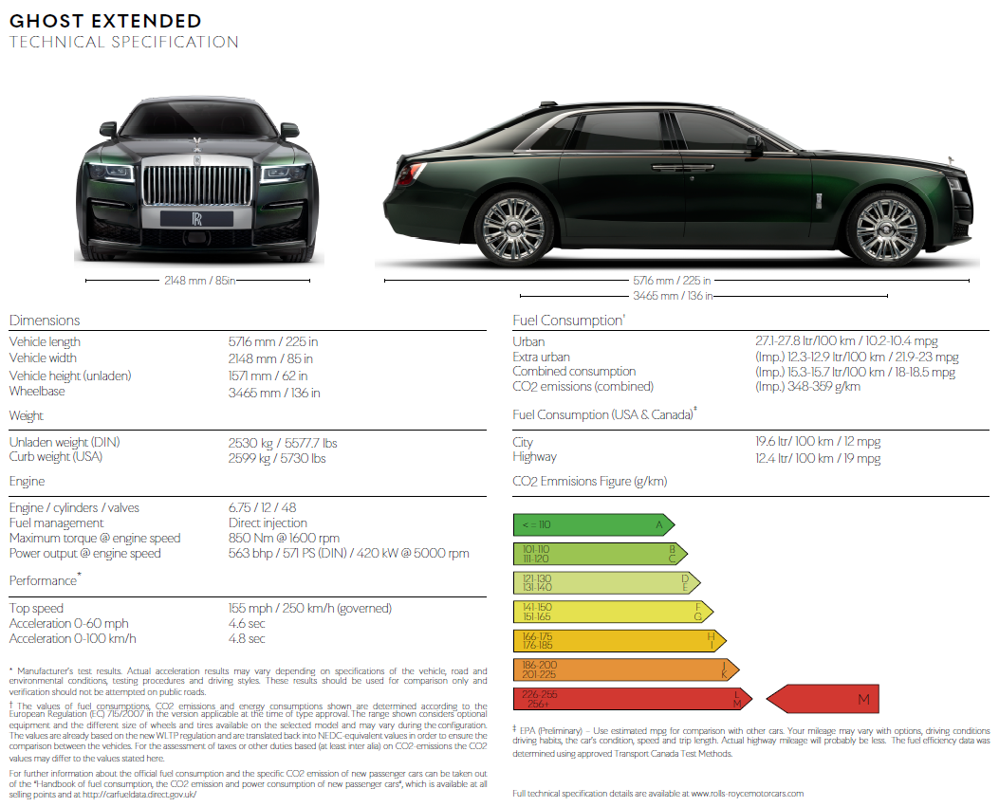
TECHNICAL SPECIFICATIONS

FURTHER INFORMATION
You can find all our press releases and press kits, as well as a wide selection of high resolution, downloadable photographs and video footage at our media website, PressClub.

EDITORS’ NOTES
Rolls-Royce Motor Cars is a wholly-owned subsidiary of the BMW Group and is a completely separate company from Rolls-Royce plc, the manufacturer of aircraft engines and propulsion systems. Over 2,000 skilled men and women are employed at the Rolls-Royce Motor Cars’ head office and manufacturing plant at Goodwood, West Sussex, the only place in the world where the company’s super-luxury motor cars are hand-built.

CONTACTS | Goodwood

Director of Global Communications
Richard Carter
+44 (0) 1243 384060
richard.carter@rolls-roycemotorcars.com
Head of Global Product Communications
Matthew Jones
+44 (0) 7815 245929
matthew.jones@rolls-roycemotorcars.com
Head of Corporate Relations
Andrew Ball
+44 (0) 7185 244064
andrew.ball@rolls-roycemotorcars.com
Head of Corporate Relations
Emma Rickett
+44 (0) 7815 244061
emma.rickett@rolls-roycemotorcars.com
Head of Global Digital, Online & Social PR Communications
Terence Church
+44 (0) 7815 245930
terence.church@rolls-roycemotorcars.com

CONTACTS | Regional

Asia Pacific – North
Rosemary Mitchell
+81 (0) 3 6259 8888
rosemary.mitchell@rolls-roycemotorcars.com
Asia Pacific – South
Hal Serudin
+65 6838 9675
hal.serudin@rolls-roycemotorcars.com
China
Anna Xu
+86 10 84558037
anna.xu@rolls-roycemotorcars.com
Eastern Europe
Frank Tiemann
+49 (0) 89 382 29581
frank.tiemann@rolls-roycemotorcars.com
Middle East and Africa
Rami Joudi
+971 56 171 7883
rami.joudi@rolls-roycemotorcars.com

North America and South America
Gerry Spahn
+1 201 930 8308
gerry.spahn@rolls-roycemotorcarsna.com
Northern Europe and Scandinavia
Ruth Hucklenbroich
+49 (0) 89 382 60064
ruth.hucklenbroich@rolls-roycemotorcars.com
Russia
Malika Abdullaeva
+7 916 449 86 22
malika.abdullaeva@press.rolls-roycemotorcars.ru

