ROLLS-ROYCE | BESPOKE INSIGHTS

THE AUTO CHINA COLLECTIVE
CANVAS: GHOST, BLACK BADGE CULLINAN, WRAITH BLACK BADGE
MEDIUM: PARQUETRY, PAINT, EMBROIDERY, BESPOKE LUGGAGE

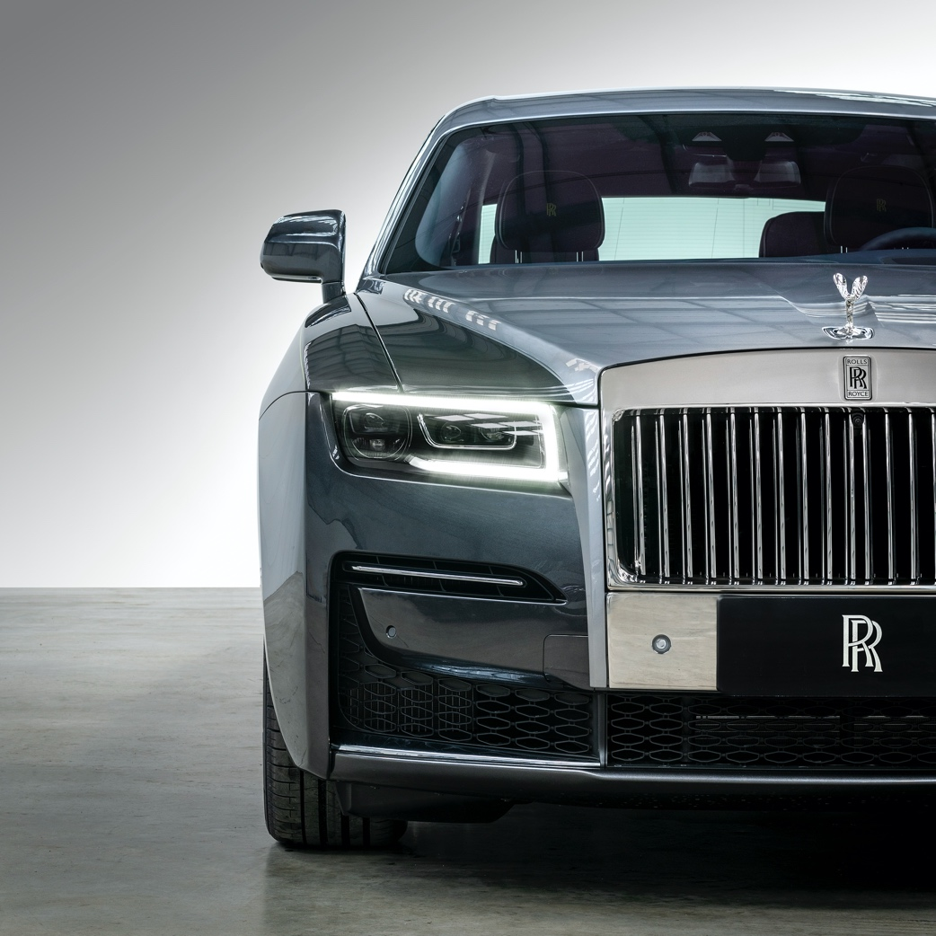
COLLECTIVE OF THREE MOTOR CARS CELEBRATE THE BREADTH OF CONTEMPORARY BESPOKE CRAFTSMANSHIP AT AUTO CHINA, SHANGHAI

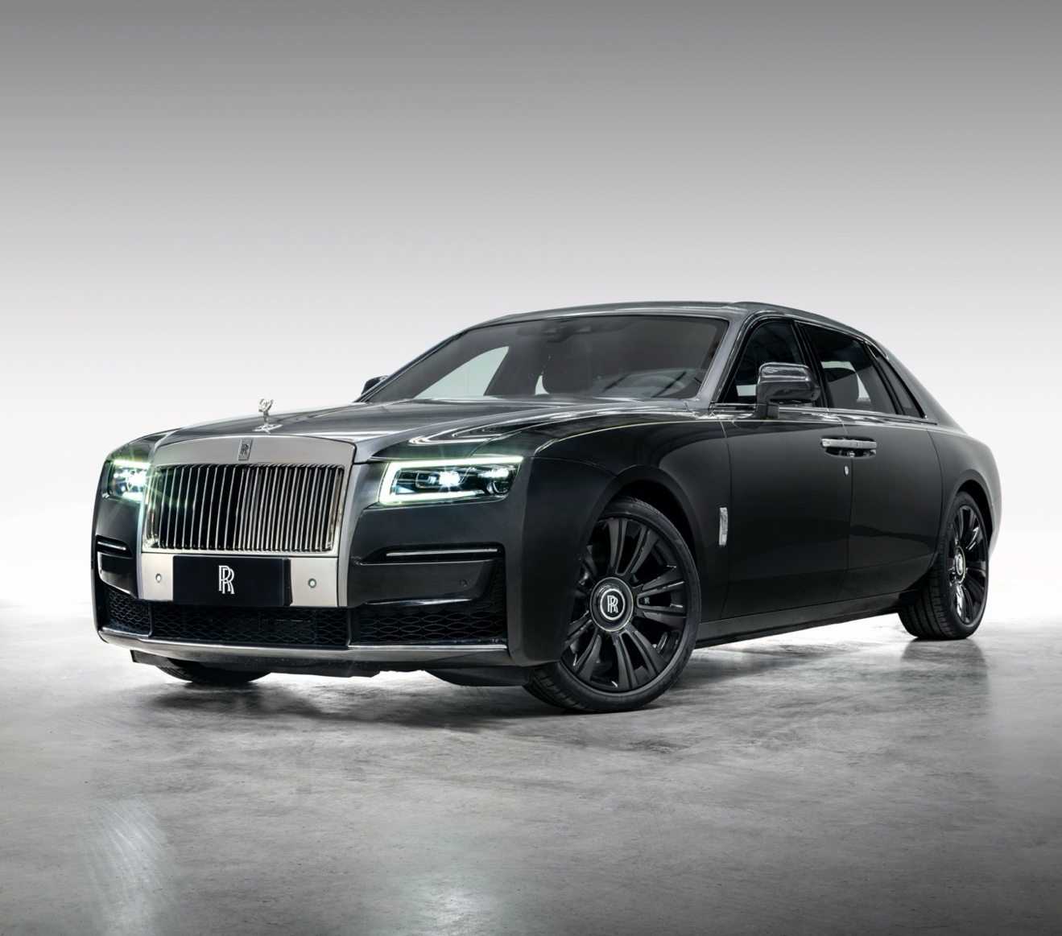

April 19th 2021, Goodwood, West Sussex

Rolls-Royce will return to Auto China, Shanghai, in 2021, presenting the near-infinite possibilities of Bespoke that underpin the marque’s continued success. This remarkable collective of three motor cars is bookended by a bold, one-of-one Black Badge Cullinan and a celebration of the contemporary sanctuary of new Ghost, representing the breadth of character afforded by truly personal expressions of luxury.

NEW GHOST EXTENDED URBAN SANCTUARY

Following a highly successful introduction to market in 2020, new Ghost Extended has embarked on its Bespoke journey. Further exploring its Post Opulent design philosophy, which celebrates material substance, not overt statement, Urban Sanctuary debuts an elevated expression of Parquetry. Recalling the ‘cracked ice’ effect of the wooden window shutters on a pavilion building within Shanghai’s storied Yu Yuan Gardens, this geometric mosaic of wood pieces is finished in un-lacquered open pore Obsidian Ayous veneer. The ‘cracked ice’ theme is also referenced by way of Bespoke embroidered panels in the seat inserts.

The interior suite also employs a front-to-back Navy Blue and Cashmere Grey two-tone colourway, creating a unique experience whether the motor car is being self-driven or chauffeur driven. The chauffeur-driven experience is further underscored by reclinable Serenity Seating with calf rests, emulating the configuration provisioned by private jets. This elegant treatment is scythed with Lime Green contrast stitching; a theme that continues into the luggage compartment where a Bespoke Luggage set is stowed, finished in matching Navy Blue canvas, Cashmere Grey hide and Lime Green contrast. True to type, Urban Sanctuary’s coachwork is finished in a gracefully subdued Gunmetal and Jubilee Silver two tone with a vibrant Lime Green coachline and wheel pinstripe, referencing the neon nights of Shanghai by night.

BLACK BADGE CULLINAN MID-CENTURY MODERN

The marque’s Bespoke Designers cite the bold colours applied to esteemed mid-century artefacts such as the Fender Stratocaster and Eames Rocking Chair as references for Black Badge Cullinan’s Bespoke Segano Green coachwork. Demonstrating that the subversive Black Badge series of motor cars are frequently rendered in colours far beyond Black, this vibrant expression of the Rolls-Royce of SUVs also incorporates a Bespoke Serenity Green and contrasting Black interior colourway, punctuated with a Technical Fibre veneer.

WRAITH BLACK BADGE POP EXPLOSION

For the most powerful Rolls-Royce ever created, Wraith Black Badge, the Rolls-Royce
Bespoke Collective of Designers, Engineers and Craftspeople found inspiration in dramatic use of colour. The two-tone Bespoke GT Blue and Arctic White coachwork is finished with a hand-painted Koi Red coachline and resolved with a bold motif, inspired by a volcanic eruption against a menacing blue sky. Flashes of Koi Red are also presented on the Muscari Blue and Arctic White interior suite. To further dramatise the ambience, a red Starlight Headliner was selected. Additionally, the motor car’s Technical Fibre fascia veneer has been hand-painted with a geometric pattern inspired by skyscraper windows illuminated by night, the rear ‘Waterfall’ between the two rear seats is embellished with embroidery recalling the exterior motif, while the seat piping is finished in Koi Red.
-ENDS-
TECHNICAL SPECIFICATIONS
- Ghost Extended: NEDCcorr (combined)CO2 emission: 343g/km; Fuel consumption: 18.8 mpg/15.0 l/100km; WLTP(combined)CO2 emission: 347-359g/km; Fuel consumption: 17.9-18.6mpg/15.2-15.8l/100km
- Black Badge Cullinan: NEDCcorr (combined) CO2 emission: 341 g/km; Fuel consumption: 18.8 mpg / 15.0 l/100km; WLTP (combined) CO2 emission: 377-355 g/km; Fuel consumption: 17.0-18.1 mpg / 16.62-15.6 l/100km
- Wraith Black Badge: NEDCcorr (combined) CO2 emission: 367 g/km; Fuel consumption: 17.5 mpg / 16.1 l/100km; WLTP (combined) CO2 emission: 370-365 g/km; Fuel consumption: 17.2-17.4 mpg / 16.4-16.2 l/100km

FURTHER INFORMATION
You can find all our press releases and press kits, as well as a wide selection of high resolution, downloadable photographs and video footage at our media website, PressClub.
You can also follow marque on social media: LinkedIn; YouTube; Twitter; Instagram; and Facebook.

EDITORS’ NOTES
Rolls-Royce Motor Cars is a wholly-owned subsidiary of the BMW Group and is a completely separate company from Rolls-Royce plc, the manufacturer of aircraft engines and propulsion systems. Over 2,000 skilled men and women are employed at the Rolls-Royce Motor Cars’ head office and manufacturing plant at Goodwood, West Sussex, the only place in the world where the company’s super-luxury motor cars are hand-built.

CONTACTS | goodwood

Director of Global Communications
Richard Carter
+44 (0) 1243 384060 / Email
Head of Corporate Relations
Andrew Ball
+44 (0) 7185 244064 / Email
Head of Global Lifestyle Communications
Emma Rickett
+44 (0) 7815 244061 / Email
Head of Global Product Communications
Matthew Jones
+44 (0) 7815 245929 / Email

CONTACTS | REGIONAL
Asia Pacific – North
Rosemary Mitchell
+81 (0) 3 6259 8888 / Email
Asia Pacific – South
Hal Serudin
+65 8161 2843 / Email
Central and Western Europe
Ruth Hilse
+49 (0) 89 382 60064 / Email
Central/Eastern Europe and CIS
Frank Tiemann
+49 (0) 160 9697 5807 / Email
China
Anna Xu
+86 10 84558037 / Email
Middle East and Africa
Rami Joudi
+971 56 171 7883 / Email
Russia
Malika Abdullaeva
+7 916 449 86 22 / Email
The Americas
Gerry Spahn
+1 201 930 8308 / Email

