ROLLS-ROYCE | MEDIA INFORMATION

ROLLS-ROYCE ANNOUNCES BLACK BADGE GHOST
THE PUREST BLACK BADGE YET

28 October 2021, Goodwood, West Sussex Embargoed until 13:00 BST

- Black Badge Ghost debuts dark side of Post Opulent design
- 6.75-litre V12 engine now delivers increased power (600PS) and torque (900NM)
- Drivetrain and chassis re-engineered for more urgent performance
- Curated collection debuts striking Turchese Leather and Technical Carbon veneer
- Bespoke alloy wheel introduced in Black Badge house style with carbon fibre barrel
- Infinity lemniscate symbol continues to codify noir expression of Rolls-Royce
“After considerable internal debate, Rolls-Royce announced that it would create an officially sanctioned response to a new kind of client: a permanent Bespoke treatment to its motor cars named Black Badge. These products, which were launched in 2016, would be darker in aesthetic, more urgent in personality and dramatic in material treatment.
“In the five years since Black Badge became publicly available, this bold family of motor cars has come to symbolise the pinnacle of a new type of super-luxury product, setting in motion a shift across the wider luxury industry. Subsequently, nearly all luxury makers create products that seek to capture the Black Badge spirit.
“Today, we announce a product that represents a new kind of Black Badge motor car, one that seizes on the minimalist, Post Opulent design treatment that has recast the legend of Ghost but amplifies and subverts it with the application of black. Our most advanced motor car yet has been reengineered to characterise the alter ego of Rolls-Royce: assertive, dynamic and potent. This is the purest Black Badge motor car in the marque’s history. This is Black Badge Ghost.”
Torsten Müller-Ötvös, Chief Executive Officer, Rolls-Royce Motor Cars

INTRODUCTION
Rolls-Royce Motor Cars has a unique fluency in its clients. Its close relationship with the women and men who patronise the marque affords the company’s decision-makers an unparalleled understanding of the super-luxury consumer: their aesthetic preferences, uncompromising lifestyle requirements and changing taste patterns. Only with this understanding, and briefings supplied by the brand's Luxury Intelligence Unit, is the marque able to create an accurate product response. Black Badge is a vivid example of this.

Rolls-Royce Motor Cars has always attracted subversive clients – rebellious women and men who built their success by breaking rules, taking risks and challenging conventions. In the 2020s, these women and men engage with luxury products on their own terms. They reject suits for streetwear, use blockchain not banks and influence the analogue world through their digital endeavours. In doing so, they have created new codes of luxury that resonate with their sensibilities: darker in aesthetic, assertive in character and bold in design.

Their approach to Rolls-Royce products is no different. The marque has responded accordingly, developing new colour palettes, more technical surface treatments and even more powerful driving experiences without ever compromising the effortless sensibilities that have drawn this bold group of clients to the Rolls-Royce brand.

Black Badge, the highly successful alter ego of Rolls-Royce, now represents more than 27% of commissions worldwide and is codified by the mathematical symbol that represents a potential infinity, which is found within the motor car’s interior. This graphic, also known as the Lemniscate, was applied to Sir Malcolm Campbell’s record-breaking Rolls-Royce-powered Blue Bird K3 hydroplane and the marque's designers nominated this hallmark for Black Badge motor cars to reflect their own unrelenting pursuit of power.
Rolls-Royce debuted Black Badge with Wraith and Ghost in 2016, followed by Dawn in 2017 then Cullinan in 2019. Today, a new, Post Opulent expression of Black Badge joins the family. The purest and most technologically advanced Black Badge motor car yet, Black Badge Ghost.

THE DARK SIDE OF POST OPULENCE
Conceived in response to a group of clients who requested a Rolls-Royce that was agile, discreet, highly connected and free of any superfluous design, the new Ghost is not just the most technologically advanced Rolls-Royce yet, but also the most aesthetically pure. In the twelve months since this motor car has been available, it has become one of the fastest-selling products in the marque’s history, representing more than 3,500 commissions worldwide.
This motor car also started a new design conversation in its relentless pursuit of minimalism and purity. Named ‘Post Opulence’ by Rolls-Royce designers, this aesthetic movement is characterised by reduction and substance. In service to this, exceptional materials are selected and celebrated while overt design is limited, intelligent and unobtrusive.
However, within this group of clients – who celebrate minimalism and material substance – a rebellious subset sought to create a disruptive expression of Ghost by permanently cloaking it in a shade so pure that its very classification as a colour remains a subject of debate: black. Black Badge Ghost reflects these clients’ desires. It is the dark side of Post Opulence: minimalism in extremis.

EXTERIOR
Clients are free to select any of the marque’s 44,000 ‘ready-to-wear’ colours or create their own entirely unique Bespoke hue. However, the overwhelming majority of women and men who requested this darker expression of Ghost have selected the signature Black. To create what is the motor car industry’s darkest black, 100lbs (45kg) of paint is atomised and applied to an electrostatically charged body in white before being oven dried. The motor car then receives two layers of clear coat before being hand-polished by a team of four craftsman to produce the marque’s signature high-gloss piano finish.
At between three and five hours in duration, this operation is entirely unknown in mass production, creating an intensity simply unattainable elsewhere in the automotive industry. It is this depth of darkness that serves as the perfect canvas for clients to add a high-contrast, hand-painted Coachline, which has done much to create the Black Badge ‘black and neon’ aesthetic that has come to characterise this vivid family of Rolls-Royce motor cars.
To match this dramatic coachwork, the marque’s Bespoke Collective of designers, engineers and craftspeople collaborated to create an entirely customisable process that allows Rolls-Royce hallmarks such as the high-polished Spirit of Ecstasy and Pantheon Grille to be subverted. Instead of simply painting these components, a specific chrome electrolyte is introduced to the traditional chrome plating process that is co-deposited on the stainless-steel substrate, darkening the finish. Its final thickness is just one micrometre – around one hundredth of the width of a human hair. Each of these components is precision-polished by hand to achieve a mirror-black chrome finish before it is fitted to the motor car.
The exterior treatment resolves with a Bespoke 21-inch composite wheelset. Designed in the Black Badge house style and reserved for Black Badge Ghost, the barrel of each wheel is made up of 22 layers of carbon fibre laid on three axes, then folded back on themselves at the outer edges of the rim, forming a total of 44 layers of carbon fibre for greater strength. A 3D-forged aluminium hub is bonded to the rim using aerospace-grade titanium fasteners and finished with the marque’s hallmark Floating Hubcap, ensuring the Double R monogram remains upright at all times. To celebrate the material substance and remarkable surface effect, a lightly tinted lacquer is applied to protect the finish but still allow clients to observe the technical complexity of the wheels unique carbon fibre construction.

INTERIOR
Advanced luxury materials have been meticulously created and crafted for a unique ambience in the interior suite. While recalling the dramatic mechanical intent of Black Badge Ghost, the materials are true to Ghost’s Post Opulent design philosophy – one defined by authenticity and material substance rather than overt statement. In this spirit, a complex but subtle weave that incorporates a deep diamond pattern rendered in carbon and metallic fibres has been created by the marque’s craftspeople.
Multiple wood layers are pressed onto the interior component substrates, using black Bolivar veneer for the uppermost base layer. This forms a dark foundation for the Technical Fibre layers that follow. Leaves woven from resin-coated carbon and contrasting metal-coated thread laid in a diamond pattern are applied by hand to the components in perfect alignment, creating a three-dimensional effect. To secure this extraordinary veneer, each component is cured for one hour under pressure at 100°C. This is then sand-blasted to create a keyed surface for six layers of lacquer, which is hand-sanded and polished before being incorporated into the motor car.
If specified in the client’s commission, the Technical Fibre ‘Waterfall’ section of the individual rear seats receives the Black Badge family motif: the mathematical symbol that represents potential infinity known as a Lemniscate. Rendered in aerospace-grade aluminium on the lid of Black Badge Ghost’s Champagne cooler, it is applied between the third and fourth layer of a total of six layers of subtly tinted lacquer, creating the illusion that the symbol is floating above the Technical Fibre veneer.
Aesthetes from the marque’s design team elected to further enhance the noir ambience of Black Badge Ghost by subduing the brightwork. Air vent surrounds on the dashboard and in the rear cabin are darkened using physical vapour deposition, one of the few methods of colouring metal that ensures parts will not discolour or tarnish over time or through repeated use. The Post Opulent principles of simplicity have also been applied to dramatic effect in the Black Badge Ghost timepiece design: only the tips of the hands and the twelve, three, six and nine o'clock markers are picked out, in a subdued chrome finish, creating a remarkably minimal clock. Additional timepieces are available within Black Badge Ghost to suit the client’s aesthetic preference.
The timepiece is flanked by a world-first Bespoke innovation that debuted with Ghost: the Illuminated Fascia, which displays an ethereal glowing Lemniscate, surrounded by more than 850 stars. Located on the passenger side of the dashboard, the constellation and motif are completely invisible when the interior lights are not in operation. As in Ghost, the Lemniscate motif is illuminated via 152 LEDs mounted above and beneath the fascia, each meticulously colour-matched to the cabin’s clock and instrument dial lighting. To ensure the Lemniscate is lit evenly, a 2mm-thick light guide is used, featuring more than 90,000 laser-etched dots across the surface. This not only disperses the light evenly but creates a twinkling effect as the eye moves across the fascia, echoing the subtle sparkle of the Shooting Star Starlight Headliner.

ENGINEERING
Black Badge is not just an aesthetic – it is an experience. The clients who requested this motor car demanded that the Bespoke treatment of Black Badge Ghost extend from the design atelier into the marque’s engineering department. In doing so, the Bespoke Collective of designers, engineers and craftspeople collaborated to create a vivid driving personality that matched Black Badge Ghost’s visual intent without compromising the marque’s effortless ride proclivities and exhaustive acoustic tuning.
Key to its potent character is the Architecture of Luxury, Rolls-Royce’s proprietary all-aluminium spaceframe architecture that debuted with Phantom. This sub-structure not only delivers extraordinary body stiffness, but its flexibility and scalability allowed Ghost to be equipped with all-wheel drive, four-wheel steering and the award-winning Planar Suspension system. For Black Badge, these peerless engineering qualities have been comprehensively re-engineered, including the fitting of more voluminous air springs to alleviate body roll under more assertive cornering.
The capacity of the Rolls-Royce twin-turbocharged 6.75-litre V12 engine was deemed sufficient. However, the flexibility of this celebrated power plant has been exploited to generate an extra 29PS, creating a total output of 600PS. The sense of a single infinite gear has also been dramatised with the addition of a further 50NM of torque, for a total of 900NM. The powertrain has also received Bespoke transmission and throttle treatments to further enhance the engine’s increased power reserves. The ZF eight-speed gear box and both front- and rear-steered axles work collaboratively to adjust the levels of feedback to the driver, depending on throttle and steering inputs.
As with all products in the marque’s Black Badge portfolio, the ‘Low’ button situated on the gear selection stalk unlocks Black Badge Ghost’s full suite of technologies. This is asserted by the amplification of the motor car's engine through an entirely new exhaust system, subtly announcing its potency. All 900NM of torque is available from just 1700rpm and, once underway in Low Mode, gearshift speeds are increased by 50% when the throttle is depressed to 90%, delivering Black Badge Ghost’s abundant power reserves with dramatic immediacy.
To bolster confidence when exploiting Black Badge Ghost, the braking bite point has been raised and pedal travel decreased. Non-Black Badge Ghost is provisioned with a robust braking hardware package that was deemed more than ample under extreme conditions, even accounting for the Black Badge alter ego’s increased power output. However, a new suite of bold high-temperature brake calliper paint colours has been developed in preparation for forthcoming Black Badge Ghost commissions.
Black Badge Ghost is available to commission now.

- ENDS -

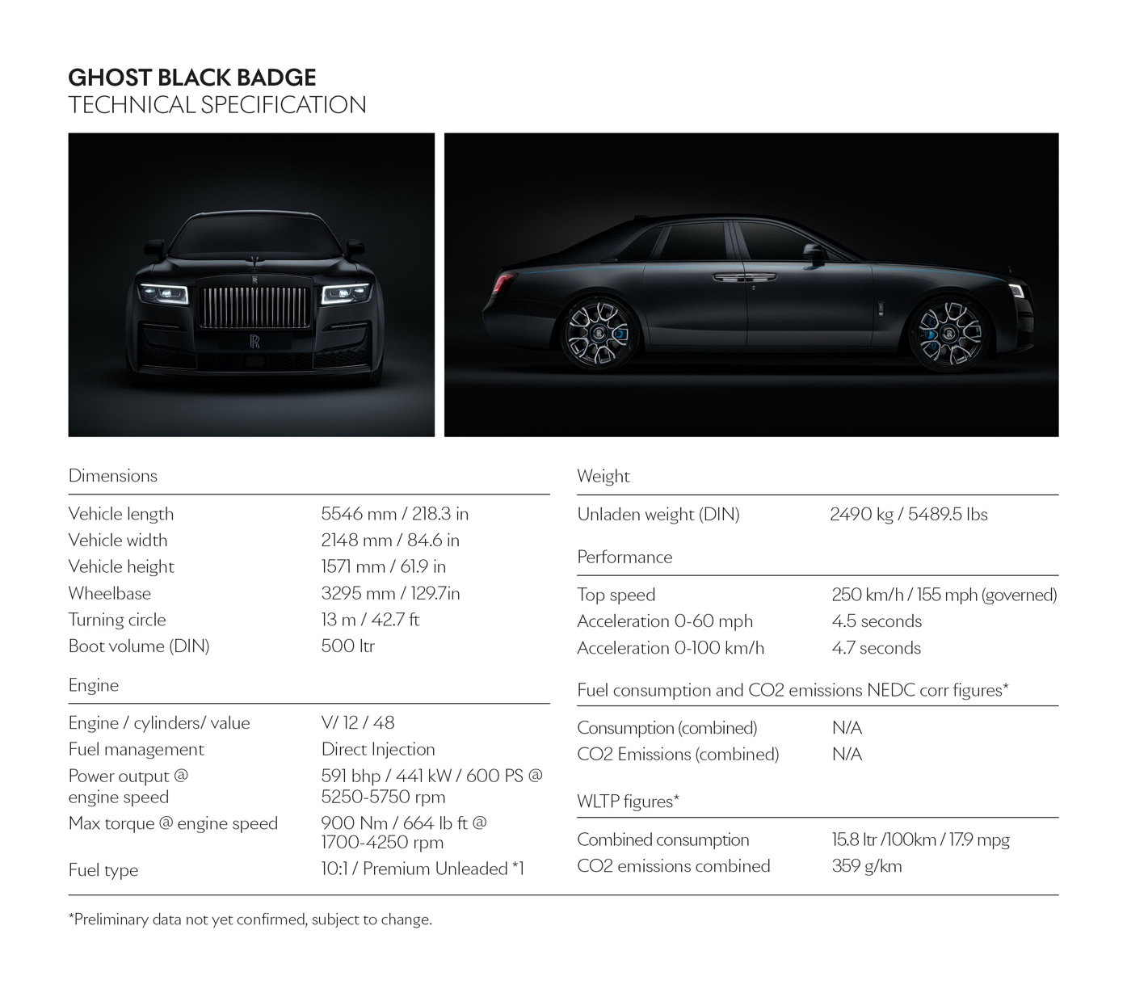
TECHNICAL SPECIFICATIONS

Black Badge Wraith: NEDCcorr (combined) CO2 emission: 367 g/km; Fuel consumption: 17.5 mpg / 16.1 l/100km; WLTP (combined) CO2 emission: 370-365 g/km; Fuel consumption: 17.2-17.4 mpg / 16.4-16.2 l/100km.
Black Badge Dawn: NEDCcorr (combined) CO2 emission: 371 g/km; Fuel consumption: 17.3 mpg / 16.3 l/100km WLTP (combined) CO2 emission: 382-380 g/km; Fuel consumption: 16.7-16.9 mpg / 16.9-16.8 l/100km.
Black Badge Cullinan: NEDCcorr (combined) CO2 emission: 341 g/km; Fuel consumption: 18.8 mpg / 15.0 l/100km WLTP (combined) CO2 emission: 377-355 g/km; Fuel consumption: 17.0-18.1 mpg / 16.62-15.6 l/100km.
Black Badge Ghost: NEDCcorr (combined) CO2 emission: 359 g/km; Fuel consumption: 15.8 mpg / 18.0 l/100km. WLTP (combined) CO2 emission: 359 g/km; Fuel consumption: 17.9 mpg / 15.8 l/100km.

FURTHER INFORMATION
You can find all our press releases and press kits, as well as a wide selection of high resolution, downloadable photographs and video footage at our media website, PressClub.
You can also follow marque on social media: LinkedIn; YouTube; Twitter; Instagram; and Facebook.

EDITORS’ NOTES
Rolls-Royce Motor Cars is a wholly-owned subsidiary of the BMW Group and is a completely separate company from Rolls-Royce plc, the manufacturer of aircraft engines and propulsion systems. Over 2,000 skilled men and women are employed at the Rolls-Royce Motor Cars’ head office and manufacturing plant at Goodwood, West Sussex, the only place in the world where the company’s super-luxury motor cars are hand-built.

CONTACTS | Goodwood

Director of Global Communications
Richard Carter
+44 (0) 1243 384060 / Email
Head of Corporate Relations
Andrew Ball
+44 (0) 7185 244064 / Email
Head of Global Lifestyle Communications
Emma Rickett
+44 (0) 7815 244061 / Email
Head of Global Product Communications
Matthew Jones
+44 (0) 7815 245929 / Email
United Kingdom
Isabel Matthews
+44 (0) 7815 245127 / Email

CONTACTS | REGIONAL
Asia Pacific – North
Rosemary Mitchell
+81 (0) 3 6259 8888 / Email
Asia Pacific – South
Hal Serudin
+65 8161 2843 / Email
Central and Western Europe
Ruth Hilse
+49 (0) 89 382 60064 / Email
Central/Eastern Europe and CIS
Frank Tiemann
+49 (0) 160 9697 5807 / Email
China
Anna Xu
+86 10 84558037 / Email
Middle East and Africa
Rami Joudi
+971 56 171 7883 / Email
Russia
Malika Abdullaeva
+7 916 449 86 22 / Email
The Americas
Gerry Spahn
+1 201 930 8308 / Email

