ROLLS-ROYCE │ BESPOKE INSIGHTS
rare, precious and emotionally resonant luxury:
AN EXTRAORDINARY year for rolls-royce bespoke

#BespokeIsRollsRoyce
15 February 2023, Goodwood, West Sussex Embargo to 13.00 GMT
- Rolls-Royce Motor Cars reflects on an unprecedented year of success for its Bespoke operations
- Individual projects included some of the most aesthetically ambitious and technically demanding ever undertaken
- All created and realised by the Rolls-Royce Bespoke Collective of specialist designers, engineers and craftspeople based at the Home of Rolls-Royce at Goodwood

“Bespoke IS Rolls-Royce, and 2022 was a landmark year in which we recorded the highest value of Bespoke commissions in our history. Reaffirming Rolls-Royce's position as a true House of Luxury and guided by our clients’ imaginations, we brought to life some truly extraordinary examples of our unique craft, each one entirely personal, meaningful and tailor-made to its owner's requirements. Our Bespoke capabilities are unrivalled and unavailable anywhere else in the world, reflected in the fact that our clients are happy to pay, on average, around half a million Euros for their Bespoke motor car.
“Our Bespoke Collective of designers, engineers and artisans is our greatest and most precious asset – truly exceptional people who push the boundaries of craftsmanship, material and technology in their constant pursuit of perfection. Every car which leaves the Home of Rolls-Royce is Bespoke and that is testament to their skill, craftsmanship and boundless creativity.”
Torsten Müller-Ötvös, Chief Executive, Rolls-Royce Motor Cars
Rolls-Royce Bespoke has celebrated its most successful year in the marque’s 118-year history. Clients from around the world explored the virtually limitless possibilities of Bespoke personalisation, resulting in a record total value of commissions for a single year.
Throughout 2022, clients’ dreams were captured in rare, precious, and emotionally resonant luxury objects. Driven by their wishes and tastes, the Rolls-Royce Bespoke Collective created some of the most exquisite examples of Bespoke artistry exploring the mystery of the aurora borealis, the symbolism of orchids, the iridescent elegance of pearls and the latest fashion movements to name just a few of the inspirations for these marvellous works of art.
Every Rolls-Royce hand-built at Goodwood is a Bespoke motor car, made to the precise wishes of the client. Commissioning a Rolls-Royce motor car is an intensely personal – and in some cases very private – process, with many clients preferring to keep their masterpiece to themselves, rather than revealing it to the public gaze. The ten examples shown below, therefore, are a very small selection of the marvellous creations designed and hand-built at the Home of Rolls-Royce. However, they represent some of the finest examples of Bespoke craftsmanship created in 2022, reflecting the marque’s stature as a true House of Luxury.

PHANTOM ‘THE SIX ELEMENTS’
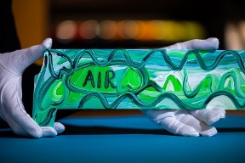  Phantom ‘The Six Elements’,  Air Gallery by Sacha Jafri  Rolls-Royce Bespoke Collective, 2022  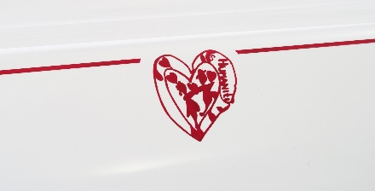  Phantom ‘The Six Elements’,  Humanity, Coachline motif  Rolls-Royce Bespoke Collective, 2022 | ‘The Six Elements’ series demonstrates the unparalleled opportunities offered by the Phantom Gallery. Each of the six one-of-one Phantoms includes a unique artwork hand-painted by world-renowned British artist Sacha Jafri.  Known for his ‘Magical Realism’ style, Sacha Jafri created emotional and colourful pieces distilling the most potent components of nature: Earth, Fire, Wind, Water and Air alongside the sixth element, Humanity.  This unique artistic project raised $1.2m for charity; a unique digital collectible contained within each Phantom makes this series ‘the Rolls-Royce that keeps on giving’.
AURORA BOREALIS WRAITHS
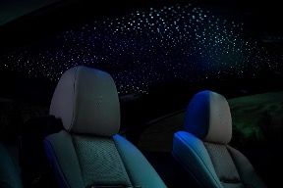  Aurora Borealis Wraiths,  Rolls-Royce Bespoke Collective, 2022  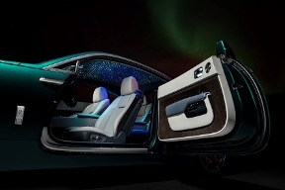  Aurora Borealis Wraiths,  Rolls-Royce Bespoke Collective, 2022 | Inspired by the breathtaking spectacle of the northern lights, these two Bespoke Wraiths capture the essence of nature’s celebrated light show. Eager to capture the ethereal splendour of this natural wonder, the Bespoke Collective developed two new paint hues – Aurora Blue and Borealis Green – reflecting the iridescent beauty of the night-time polar display.  Inside, each Wraith features multicoloured Starlight Headliners with a constellation of blue, green and white fibreoptic ‘stars’. The Bespoke Collective invested many hours to achieve the perfect positioning of the lights, evoking the ethereal beauty of the aurora borealis.
PHANTOM PAISLEY GALLERY
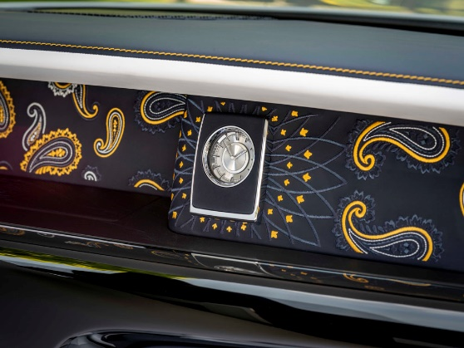  Phantom Paisley Gallery  Rolls-Royce Bespoke Collective, 2022 | This one-off Gallery illustrates a beautiful, stitched artwork reinterpreting the intricate paisley motif that has adorned luxury items for centuries. Entirely hand-embroidered using Navy Blue, Arctic White and Forge Yellow thread, it contains 90,000 individual stitches, blending run stitching and satin bordering to create texture, and took over 40 hours to complete. Each piece consists of three seamlessly connected elements, positioned with millimeter-perfect precision.
CULLINAN FROZEN LAKES
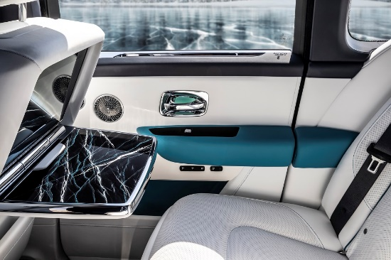  Cullinan Frozen Lakes, picnic tables, cracked ice motif, Rolls-Royce Bespoke Collective, 2022  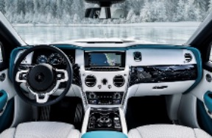  Cullinan Frozen Lakes,  Rolls-Royce Bespoke Collective, 2022 | These Bespoke Cullinans immerse their occupants in the magical ambience of a winter wonderland. The fascia and the picnic tables are meticulously hand-painted with a motif inspired by the patterns of cracked ice, with multiple layers painted in different colours, then coated and polished to create a three-dimensional effect – a process that took over two weeks to complete. Achieving a similar effect on the Bespoke Starlight Headliner took a further 18 hours.  The exterior is finished in sparkling Crystal over Midnight Sapphire and Blue Crystal over Arctic, capturing the sharpness, shimmer and depth of the ice surfaces.
PHANTOM SAPPHIRE ASTRUM GALLERY
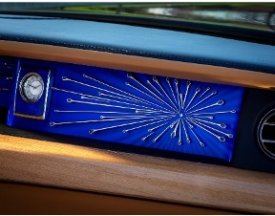  Phantom Sapphire Astrum Gallery,  Rolls-Royce Bespoke Collective, 2022 | Astrum's exquisite one-off Gallery features a starburst motif in which solid silver spears radiate from a diamond set in platinum before terminating in pear-cut sapphires.  The backing is engraved with a guilloché effect in Bleu de Nuit, a rich sapphire lacquer that intensifies the precious stones' magnificent colours. The Gallery clock’s sterling silver surround is also decorated with a guilloché pattern, with a matching Sapphire Blue lacquer overlay giving depth and iridescence to the clockface.

PEBBLE BEACH COLLECTION GHOSTS
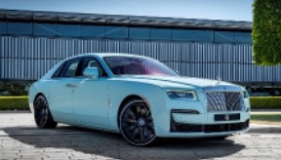  Pebble Beach Collection Ghost, Sagano Green  Rolls-Royce Bespoke Collective, 2022  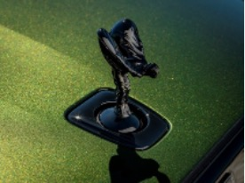 | Designed to highlight Bespoke capabilities at the world-famous Pebble Beach gathering in California, these two Ghosts showcase the iridescent nature of two sparkling finishes – Crystal over Sagano Green and a shimmering finish with gold mica flakes over Sequoia Green.  This remarkable depth of colour is achieved using six layers of finish, each meticulously polished by hand. Before the two final clear coatings are added, the Crystal finish is applied, with minute particles of colour specks creating a lustrous, multi-dimensional shimmer.
Pebble Beach Collection Ghost, Sequoia Green
Rolls-Royce Bespoke Collective, 2022
PHANTOM ORCHID – TIMELESS ELEGANCE
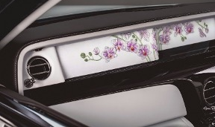  Phantom Orchid, the Gallery by Helen Amy Murray,  Rolls-Royce Bespoke Collective, 2022  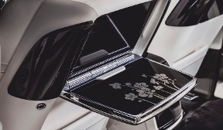 | This one-off Phantom is inspired by the Singapore Orchid – a symbol of beauty, resilience and strength. The centrepiece of this commission is a hand-sculpted Gallery created by award-winning artist, Helen Amy Murray, incorporating three-dimensional flowers made entirely of silk.  The orchid motif continues in the rear picnic table inlays and treadplates. The exterior Singapore Orchid Pearl White paint was combined with a tint of violet and fine glass particles to create a beautiful pearlescent effect, further enhanced with an Orchid coachline.
Phantom Orchid, picnic tables,
Rolls-Royce Bespoke Collective, 2022

FUX BRIGHT YELLOW DAWN
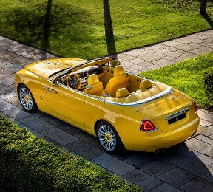 | This radiant Bespoke Dawn joins a long list of special commissions for dedicated car collector and long-standing patron of the brand, Michael Fux. The glorious Fux Bright Yellow, which has been exclusively created for his use, is celebrated throughout every element of the motor car, including the vibrant exterior finish, leather upholstery, top stitch, two-tone steering wheel and coloured wheel centres.
Fux Bright Yellow Dawn,
Rolls-Royce Bespoke Collective, 2022

PHANTOM PLATINO
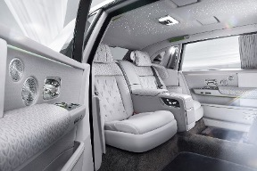  Phantom Platino,  Rolls-Royce Bespoke Collective, 2022  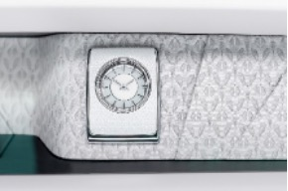  Phantom Platino, the Gallery and Bespoke clock,  Rolls-Royce Bespoke Collective, 2022 | Named after the silver-white finish of platinum, this Bespoke masterpiece features an interior combining two different fabrics – one created in an Italian mill to combine durability with a gloriously luxurious appearance, the other derived from bamboo fibres and selected for its lustrous finish.  Both materials share an original repeating pattern based on an abstract interpretation of the Spirit of Ecstasy; this motif is echoed in the Gallery. The Starlight Headliner is a one-off design in which the ‘stars’ draw the eye rearwards, with shooting stars following the pattern's sweeping arc.
CULLINAN INSPIRED BY FASHION
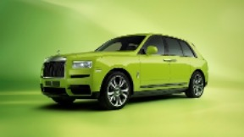  ‘Cullinan – Inspired by Fashion’ Re-Belle,  Lime Green exterior,  Rolls-Royce Bespoke Collective, 2022 | The ‘Cullinan – Inspired by Fashion’ Bespoke collection comprises two sets of four cars reflecting different aspects of fashion. The striking Re-Belle cars celebrate block colour with Lime Green, Gunmetal, Wildberry and Arctic White external finishes, and interiors featuring Lime Green or Peony Pink accents. The Fu-Shion cars are finished in Military Green, Burnout Grey, Forge Yellow and Tempest Grey with Mandarin or Forge Yellow contrasts inside.
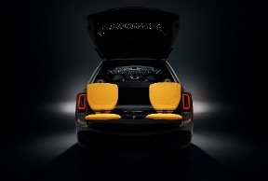 | For this commission, Bespoke designers created the all-new Starlight Tailgate. This unique feature sees 192 softly illuminated stars integrated into the perforated leather upholstery, extending the iconic Starlight Headliner beyond the interior when the tailgate is opened.
‘Cullinan – Inspired by Fashion’ Fu-Shion,
Viewing Suite and Starlight Tailgate,
Rolls-Royce Bespoke Collective, 2022

- ENDS -
TECHNICAL INFORMATION

- Phantom: NEDC combined: CO2 emissions: 345 g/km; Fuel consumption: 18.7 mpg / 15.1 l/100km. WLTP combined: CO2 emissions: 351-362 g/km; Fuel consumption: 17.7-18.2 mpg / 15.5-16.0 l/100km.

- Phantom Extended: NEDC combined: CO2 emissions: 345 g/km; Fuel consumption: 18.7 mpg / 15.1 l/100km. WLTP combined: CO2 emissions: 353 - 365 g/km; Fuel consumption: 17.4-18.1 mpg / 15.6-16.2 l/100km.

- Ghost: NEDCcorr (combined) CO2 emission: 343 g/km; Fuel consumption: 18.8 mpg / 15.0 l/100km; WLTP (combined) CO2 emission: 347-359 g/km; Fuel consumption: 17.9-18.6 mpg / 15.2-15.8 l/100km.

- Ghost Extended: NEDCcorr (combined) CO2 emission: 343g/km; Fuel consumption: 18.8 mpg / 15.0 l/100km; WLTP (combined) CO2 emission: 348-359g/km; Fuel consumption: 17.9-18.5mpg / 15.3-15.8l/100km.

- Black Badge Ghost: NEDCcorr (combined) CO2 emission: 359 g/km; Fuel consumption: 15.8 mpg / 18.0 l/100km; WLTP (combined) CO2 emission: 359 g/km; Fuel consumption: 17.9 mpg / 15.8 l/100km.

- Wraith: NEDCcorr (combined) CO2 emission: 365-363 g/km; Fuel consumption: 17.7-17.8mpg/16.0-15.9 l/100km; WLTP (combined) CO2 emission: 369-357g/km; Fuel consumption: 17.3-17.9mpg/16.3-15.8 l/100km.

- Black Badge Wraith: NEDCcorr (combined) CO2 emission: 367 g/km; Fuel consumption: 17.5 mpg / 16.1 l/100km; WLTP (combined) CO2 emission: 370-365 g/km; Fuel consumption: 17.2-17.4 mpg / 16.4-16.2 l/100km.

- Dawn: NEDCcorr (combined): CO2 emission: 372-367 g/km; Fuel consumption: 17.3-17.5 mpg / 16.3-16.1 l/100km; WLTP (combined): CO2 emission: 381-367 g/km; Fuel consumption: 16.7-17.1 mpg / 16.9-16.2 l/100km.

- Black Badge Dawn: NEDCcorr (combined) CO2 emission: 371 g/km; Fuel consumption: 17.3 mpg / 16.3 l/100km; WLTP (combined) CO2 emission: 382-380 g/km; Fuel consumption: 16.7-16.9 mpg / 16.9-16.8 l/100km.

- Cullinan: NEDCcorr (combined) CO2 emission: 348 g/km; Fuel consumption: 18.6 mpg / 15.2 l/100km WLTP (combined) CO2 emission: 377-368 g/km; Fuel consumption: 17.1-17.5 mpg / 16.5-16.1 l/100km.

- Black Badge Cullinan: NEDCcorr (combined) CO2 emission: 343 g/km; Fuel consumption: 18.7 mpg / 15.1 l/100km; WLTP (combined) CO2 emission: 377-370 g/km; Fuel consumption: 17.0-17.3 mpg / 16.6-16.3 l/100km.

FURTHER INFORMATION
You can find all our press releases and press kits, as well as a wide selection of high resolution, downloadable photographs and video footage at our media website, PressClub.

EDITORS’ NOTES
Rolls-Royce Motor Cars is a wholly-owned subsidiary of the BMW Group and is a completely separate company from Rolls-Royce plc, the manufacturer of aircraft engines and propulsion systems. Over 2,500 skilled men and women are employed at the Rolls-Royce Motor Cars’ head office and manufacturing plant at Goodwood, West Sussex, the only place in the world where the company’s super-luxury motor cars are hand-built.
CONTACTS | GOODWOOD

Director of Global Communications  Emma Begley  +44 (0) 1243 384060 / Email | Head of Global Product Communications  Georgina Cox  +44 (0) 7815 370878 / Email
Head of Corporate Relations  Andrew Ball  +44 (0) 7185 244064 / Email | Global Product PR Manager  Katie Sherman  +44(0) 7815 244896 / Email
United Kingdom and Ireland
Isabel Matthews
+44 (0) 7815 245127 / Email

CONTACTS | GLOBAL

Asia Pacific  Hal Serudin  +65 8161 2843 / Email | China  Ou Sun  +86 186 0059 0675 / Email
Central/Eastern Europe and CIS  Frank Tiemann  +49 (0) 160 9697 5807 / Email | Middle East and Africa  Rami Joudi  +971 56 171 7883 / Email
Central and Western Europe  Ruth Hilse  +49 (0) 89 382 60064 / Email | The Americas  Gerry Spahn  +1 201 930 8308 / Email

