ROLLS-ROYCE | MEDIA INFORMATION
CELEBRATING THE CENTENARY OF AN ICON:
A YEAR OF PHANTOM STORIES

18 December 2025, Goodwood, West Sussex (Embargo to 13.00 GMT)

- Rolls-Royce reflects on a year of global celebrations marking Phantom's centenary
- Debut of Phantom Centenary Private Collection: the most complex and technologically ambitious Collection yet
- Phantom client commissions for 2025 delivery reflect anniversary’s significance
- Famous historical Phantom owners from the worlds of art and music honoured
- Site extension at Goodwood creates new Bespoke possibilities for future Phantoms

“For Rolls-Royce, 2025 has revolved around the centenary of our pinnacle product, Phantom. This was a once-in-a-generation opportunity to honour the stories that built this nameplate’s legend — from the incredible motor cars themselves, the zenith of effortless motoring in their respective eras, to the towering figures in music, art, business and statecraft who have chosen a Phantom of their own. We marked this extraordinary occasion with landmark commissions and exceptional global celebrations that reflect the spirit and stature of our marque today, perfectly setting the tone for Phantom’s next 100 years.”
Chris Brownridge, Chief Executive, Rolls-Royce Motor Cars

Throughout 2025, Rolls-Royce Motor Cars has celebrated the centenary of its pinnacle product and the most famous nameplate in luxury history: Phantom. These celebrations focused on the people, places and events that shaped Phantom’s incredible story, and how this extraordinary motor car has both reflected and influenced the world around it.
Designed by Sir Henry Royce, the original ‘New Phantom’ made its debut in 1925. Over the next 100 years and throughout eight generations, Phantom has always been the grandest, most impressive and effortlessly refined motor car built by the marque: a century of unassailable luxury and engineering excellence.
The centenary year has featured appearances by all eight generations of Phantom at celebratory events across the globe, culminating in the unveiling of the Phantom Centenary Private Collection, Rolls-Royce’s own Bespoke tribute to its most storied model.
Clients around the world also chose to take delivery of their Bespoke Phantoms in 2025 – in many cases beginning the journey years in advance, in anticipation of the anniversary – ensuring their motor cars would not only become part of their personal legacy, but also take a once-in-a-lifetime place in the ongoing story of this remarkable nameplate. To mark this milestone, every Rolls-Royce Phantom hand-crafted at the Home of Rolls-Royce this year was completed with a special centenary chassis plaque.
Rolls-Royce takes this opportunity to reflect on Phantom’s legacy, revisiting the stories and moments shared among clients, the media, and the wider world throughout this centenary year.

PHANTOM CENTENARY PRIVATE COLLECTION: A BESPOKE TRIBUTE
Rolls-Royce honoured 100 years of the Phantom nameplate with the Phantom Centenary Private Collection. Limited to just 25 examples, this Private Collection combines traditional and highly innovative craft techniques to explore a century of stories: pivotal figures, notable clients, significant models, journeys, places and moments that defined Phantom’s first 100 years.
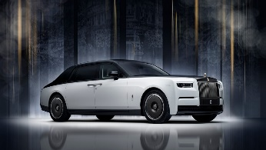  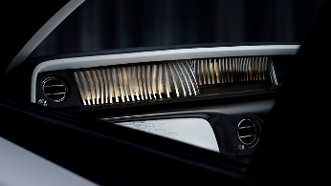  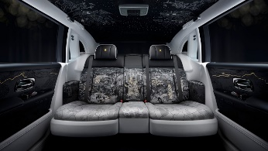  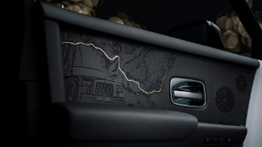 | Its iridescent two-tone exterior, finished in Super Champagne Crystal over Arctic White and Black – crowned with a solid gold Spirit of Ecstasy – recalls the elegance of Phantom’s early Hollywood era. Inside, exquisitely crafted Bespoke features tell the story of Phantom’s legend. The Anthology Gallery is composed of sculpted words selected from 100 years of media acclaim. The rear seats are finished in high-resolution printed and embroidered fabric, meticulously developed with a couture atelier over a year.  The Starlight Headliner captures historic moments and references in 440,000 stitches. The sculptural doors feature the marque’s most intricate woodwork to date, combining 3D marquetry, 3D ink layering and 24-carat gold leafing. The result is the most complex and technologically ambitious Private Collection to date – a defining statement, 100 years in the making.

CELEBRATING PHANTOM’S PLACE IN MUSIC BY BRINGING A LEGEND TO LIFE
In 2025, Rolls-Royce celebrated the legendary figures in music who chose Phantom, both as a symbol of success and a source of creative inspiration. From Marlene Dietrich and Liberace to Elvis Presley, Sir Elton John, Pharrell Williams and Curtis ‘50 Cent’ Jackson, these artists helped shape, and were drawn to, Phantom’s magnetic presence.
Perhaps the most memorable tale from Phantom’s musical mythology is Keith Moon’s infamous 21st birthday party, when The Who’s drummer reportedly drove his Rolls-Royce into a swimming pool. Though witnesses have only a hazy recollection of what really happened, a Rolls-Royce submerged in a pool became the ultimate symbol of rock ‘n’ roll indulgence.
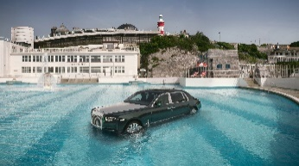 | To mark Phantom’s centenary, Rolls-Royce brought the myth to life by submerging a Phantom Extended body shell – a retired prototype destined for recycling — in the Art Deco Tinside Lido in Plymouth, England.  The location also has Beatles heritage: on 12 September 1967, The Beatles visited while filming The Magical Mystery Tour. That same year, John Lennon debuted his yellow, hand-painted Phantom V, forever linking the nameplate with music history.
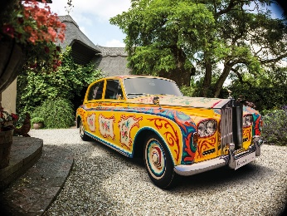
REFLECTING ON PHANTOM’S CONNECTION TO A CENTURY OF ART
As part of the centenary celebrations, Rolls-Royce reflected on Phantom’s long-standing connection to the art world. In one of the most surreal arrivals in history, Salvador Dalí once filled a friend’s Phantom with 500kg of cauliflowers, then flung open the door upon arrival at the Sorbonne in Paris, sending the brassicas cascading to the ground. This moment – which itself will celebrate its 70th anniversary on 26 December, 2025 – was commemorated by the marque, along with reflections of other Phantom owners who led the creative conversation, including Andy Warhol, who was so compelled by Phantom that he acquired a 1937 model on the spot after seeing it parked outside a Zurich antiques shop in 1972.
COMMISSIONS INSPIRED BY AN UNFORGETTABLE LEGACY
Aware of the historical significance of 2025, clients around the world placed Bespoke commissions for delivery in Phantom’s centenary year — in many cases beginning that journey years in advance. These Phantoms stand among the most ambitious ever created by the marque’s Bespoke Collective and resident designers in the Private Offices of Shanghai, Dubai, Seoul and New York, and the original at the Home of Rolls-Royce at Goodwood, West Sussex.

 | PHANTOM YEAR OF THE DRAGON
 | 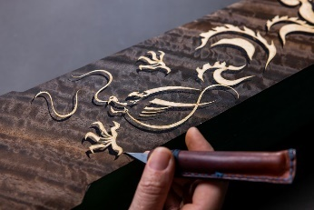  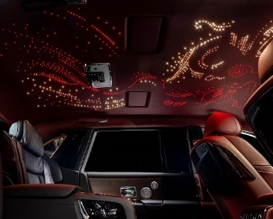 | Commissioned by a Chinese client to mark the Year of the Dragon, this one-of-one Phantom Extended is a contemporary tribute to one of China’s foundational legends. At its centre is a spectacular marquetry Gallery depicting two dragons swirling through clouds, guarding a central pearl represented by a Bespoke clock.  The dragons also appear on the Bespoke Starlight Headliner as 768 red and 576 white fibre-optic ‘stars’, each individually hand-placed.
 | PHANTOM CHERRY BLOSSOM
 | 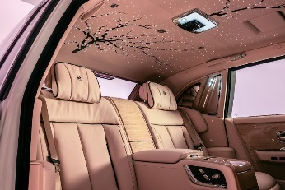 | Inspired by the Japanese tradition of Hanami, Phantom Cherry Blossom is a tribute to the fleeting beauty of springtime Sakura blooms. Commissioned by a Japanese client, the rear cabin of this Phantom Extended includes the marque’s first use of sculptural 3D embroidery, with cherry petals formed from layered, self-supporting thread structures. The Starlight Headliner is also exquisitely embroidered with cascading cherry branches, completing an interior comprising over 250,000 stitches.
 | PHANTOM DENTELLE
 | 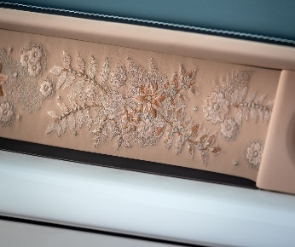 | Phantom Dentelle is a one-of-one tribute to couture lace, using embroidery to translate the material’s delicate, three-dimensional textures into the Gallery and rear Waterfall section. The interior features more than 230,000 stitches across eight embroidery techniques, combining Rose Gold, Oatmeal and Sunrise threads to evoke pearls and floral filigree.
PHANTOM CHINESE MURAL ART
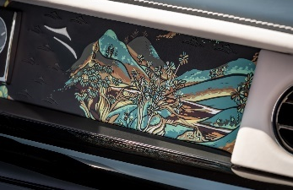  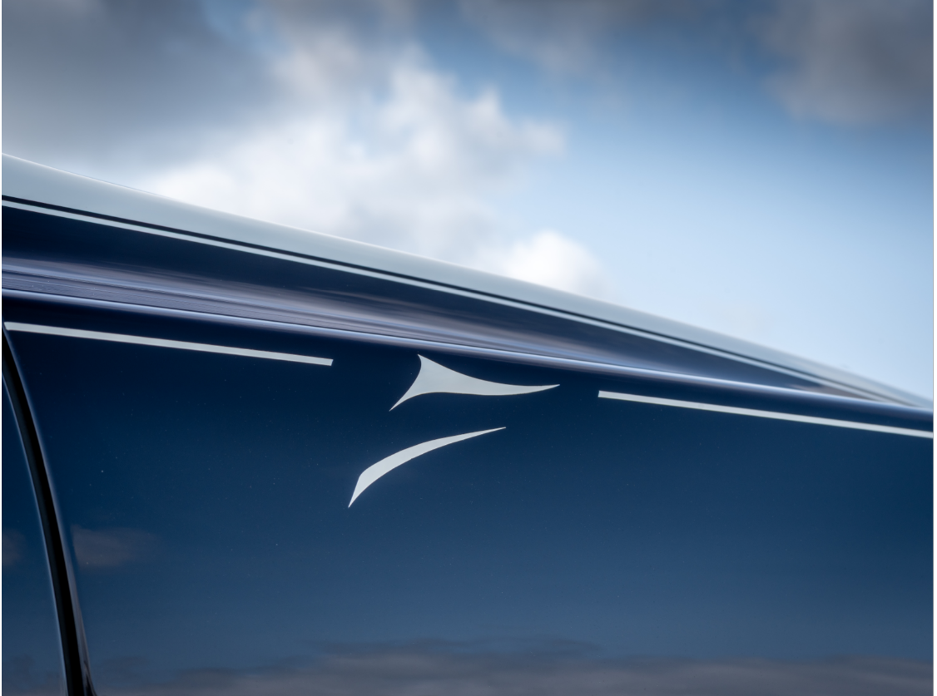 |  | One of a trio of Bespoke motor cars commissioned through Private Office Shanghai, in tribute to the ancient mural paintings of Dunhuang, China. The Phantom Extended, features a Gallery with a landscape painting on black leather, rendered in an adapted Chinese technique of reduction block printing.  The Silken Spirit motif, inspired by imperial silk and the Spirit of Ecstasy, appears in the hand-painted Coachline, interior embroidery, wood inlays and on illuminated treadplates.
A WORLD STAGE FOR PHANTOM
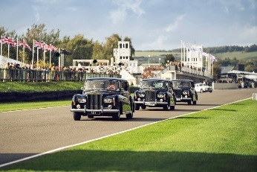  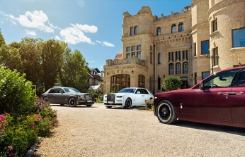  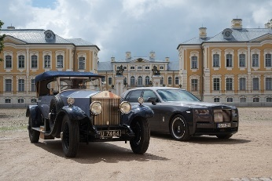  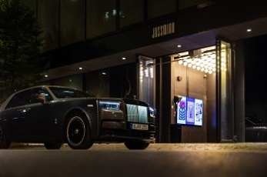  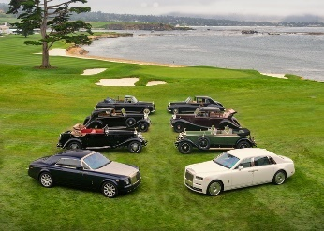  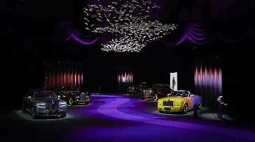  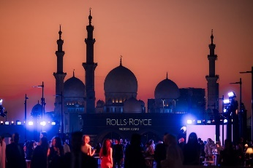  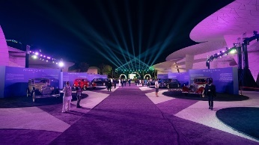 |  | Throughout its centenary year, Phantom was celebrated on a truly global stage, with commemorative events held across five continents. From prestigious concours to exclusive gatherings, these moments reflected the power of Phantom’s legacy in every sense.  The centenary journey began at the Concorso d’Eleganza Villa d’Este in Italy, followed by the Goodwood Festival of Speed and Goodwood Revival in the UK, where five historic Phantoms – including the celebrated Phantom I ‘Brougham De Ville’, or ‘Phantom of Love’ – graced the Aerodrome Lawn. In Spain, all eight generations of Phantom were showcased at the beautiful Torre Loizaga in Bilbao.  A celebratory drive across Scandinavia and the Baltics saw members of the 20-Ghost Club journey more than 2,000 kilometres from Helsinki – where the cavalcade was waved off by a Phantom VIII – through Nordic landscapes in 26 pre-War Rolls-Royces, including three examples of Phantom I. The oldest participating motor car dated from 1927.  Celebrations continued in Karlovy Vary, Czech Republic, where Phantom’s cultural role was marked at the city’s renowned film festival. In Warsaw, Poland, Rolls-Royce hosted a jazz evening featuring renowned vocalist Stacey Kent, while in Baku, Azerbaijan, an exclusive cultural club paid tribute to Phantom’s deep-rooted musical connections and its appearance in song lyrics across musical styles and generations.  In North America, Phantom’s centenary was honoured with a dedicated class at the Pebble Beach Concours d’Elegance, where eight generations of Phantom were united for this occasion. This milestone was celebrated at gatherings in Colorado Springs for the Rolls-Royce Owners' Club Annual Meet, the Las Vegas Concours d’Elegance, and the grand opening of Rolls-Royce Motor Cars Oakville in Canada.  In Asia, Rolls-Royce hosted a standout event at Azabudai Hills, Tokyo, showcasing a selection of rare Phantoms – from Phantom II Continental to Phantom Oribe, designed in collaboration with Hermès for a Japanese collector. 100 Years of Phantom was celebrated in Singapore with a contemporary culinary journey, and in Shanghai, five generations of Phantom were honoured at a showcase for Chinese clients and friends of the marque.  Across the Middle East, the Phantom Centenary made landmark appearances at the National Museum of Qatar and at private events in Dubai, Riyadh, Manama, and Abu Dhabi. These showcases included historic and modern Bespoke Phantoms such as the Phantom Drophead Coupé Zenith, Phantom Scintilla Private Collection, replete with an 869,500-stitch interior, and Phantom Centenary Private Collection.
PHANTOM’S BESPOKE FUTURE
In a year defined by Phantom’s legacy, Rolls-Royce also looked to its future. At the Home of Rolls-Royce at Goodwood, construction progressed on a landmark £300 million extension to house advanced equipment and capabilities dedicated to Bespoke. This expansion enhances every element of the marque’s creative and technical process, creating space for bold new ideas, materials and artisanal techniques. Phantom, as the marque’s pinnacle product and most expansive canvas, will continue to be where these innovations are brought to life on the grandest scale, today and into its next century.

- ENDS –

FURTHER INFORMATION
You can find all our press releases and press kits, as well as a wide selection of high resolution, downloadable photographs and video footage at our media website, PressClub.
You can also follow marque on social media: LinkedIn; YouTube; Instagram; and Facebook.

EDITORS’ NOTES
Rolls-Royce Motor Cars is a true luxury house, creating the world’s most recognised, revered and desirable handcrafted Bespoke products for its international clientele.
There are over 2,500 people working at the Home of Rolls-Royce at Goodwood, West Sussex. This comprises both its global headquarters and Centre of Luxury Manufacturing Excellence – the only place in the world where Rolls-Royce motor cars are designed, engineered and meticulously built by hand. An independent study by the London School of Economics & Political Science confirms that since the company first launched at Goodwood in 2003, it has contributed more than £4 billion to the UK economy and adds more than £500 million in economic value every year.
Rolls-Royce Motor Cars is a wholly owned subsidiary of the BMW Group and is a completely separate, unrelated company from Rolls-Royce plc, the manufacturer of aircraft engines and propulsion systems.

CONTACTS | GOODWOOD
Director of Global Communications  Emma Begley: +44 (0)1243 384060 Email | Head of Corporate Relations  Andrew Ball: +44 (0)7815 244064 Email
Head of Global Luxury and Corporate Communications  Marius Tegneby: +44 (0)7815 246106 Email | Head of Global Product Communications  Georgina Cox: +44 (0)7815 370878 Email
Global Product Communications Manager  Luke Strudwick: +44 (0)7815 245918 Email | Global Bespoke Communications  Malika Abdullaeva: +49 151 6019 7646 Email
CONTACTS | GLOBAL
The Americas  Gerry Spahn: +1 201 930 8308 Email | Asia Pacific (South) and India  Juliana Tan: +65 9695 3840 Email
Central/Eastern Europe and Central Asia  Frank Tiemann: +49 160 9697 5807 Email | Central and Western Europe  Ruth Hilse: +49 89 382 60064 Email
China  Ou Sun: +86 186 0059 0675 Email | Japan and Korea  Yuki Imamura: +81 90 5216 1957 Email
Middle East and Africa  Haya Shanata: +971 56 171 7883 Email | United Kingdom and Ireland  Isabel Matthews: +44 (0)7815 245127 Email

