ROLLS-ROYCE | MEDIA INFORMATION
ROLLS-ROYCE CREATES UNIQUE ARTWORK IN SUPPORT OF ALDINGBOURNE TRUST

Monday 9 March 2026, Goodwood, West Sussex
- Rolls-Royce Motor Cars creates unique artwork in support of local charity Aldingbourne Trust
- Digital rendering created by Rolls-Royce designer inspired by a wooden model motor car made by the Wood@Aldingbourne team
- Strictly limited run of three framed prints, all individually signed and numbered
- One will adorn the Trust’s café and one will be retained by the Wood@Aldingbourne team. The third will be auctioned at the Goodwood Members’ Meeting in April
- Project extends support for the marque’s 2024 House Charity

“It was a privilege to work with Aldingbourne Trust as our House Charity in 2024. When we presented the final donation cheque, we received an unexpected gift – a model car made in Sapele wood by the Wood@Aldingbourne team. This delightful model inspired one of our designers to create a unique digital rendering, just as we would for a real client commission. We’re delighted that this artwork will be displayed in the Trust’s café and will also be offered as a significant prize in a fundraising auction. It’s a pleasure to extend our support for this wonderful organisation beyond 2024.”
Andrew Ball, Head of Corporate Relations, Rolls-Royce Motor Cars

Rolls-Royce Motor Cars has presented Aldingbourne Trust, the marque’s House Charity in 2024, with a set of unique framed artworks produced by the Rolls-Royce design team and inspired by a handcrafted model created by the Wood@Aldingbourne team.
When Rolls-Royce presented the final donation cheque to the Trust at the end of 2024, it received an unexpected thank-you gift: a wooden model motor car made by the Wood@Aldingbourne team. Dubbed the ‘Sapele Shadow’ after the hardwood used in its construction and now displayed at the Home of Rolls-Royce at Goodwood, the model inspired one of the marque’s designers to create a unique digital image using the same rendering technology used to prepare initial visuals for clients’ real-life commissions.
Just three copies of the renderings have been produced, each framed and individually signed by the designer and numbered to guarantee their authenticity. One will be displayed in the Aldingbourne Trust café; another has been presented to the Wood@Aldingbourne team; the third will be offered in a charity auction at the Goodwood Members’ Meeting in April.
Wood@Aldingbourne is a social enterprise operating under the wider Aldingbourne Trust umbrella as a financially self-sustaining environmental group. It generates income through a wood collection service, wood and product sales and architectural salvage from local sources, including the Home of Rolls-Royce. Every piece of reclaimed wood is used productively, either transformed into unique wooden products sold in the Trust gift shop, or in its biomass boiler system.
Founded in 1978, Aldingbourne Trust provides a range of services for more than 1,500 people with learning disabilities, including autism, autism spectrum disorders and Down’s syndrome, as well as those living with physical disabilities. The charity operates more than a dozen social enterprises, including Wood@Aldingbourne, as part of its entrepreneurial approach to provide opportunities, supported living and outreach. It delivers many of its work, training and other support activities through the Aldingbourne Country Centre, a popular visitor attraction and conference venue just 10 minutes’ drive from the Home of Rolls-Royce at Goodwood.
During 2024, Rolls-Royce colleagues raised money to help fund the charity’s life-changing work. This latest project is an example of the deep, lasting relationships that grow between colleagues and their chosen House Charity and how their support can extend beyond the initial period.
Abigail Rowe, Aldingbourne Trust, said: “We were so appreciative of the fundraising efforts by Rolls-Royce staff, and the tremendous awareness we were able to generate through being their House Charity. It’s wonderful that the relationship has continued through this collaboration, which meant so much to the client who created the original wooden model, and will help raise further money for us. We’d like to thank the whole Rolls-Royce team, and particularly the talented designer who created these images for us.”

- ENDS -

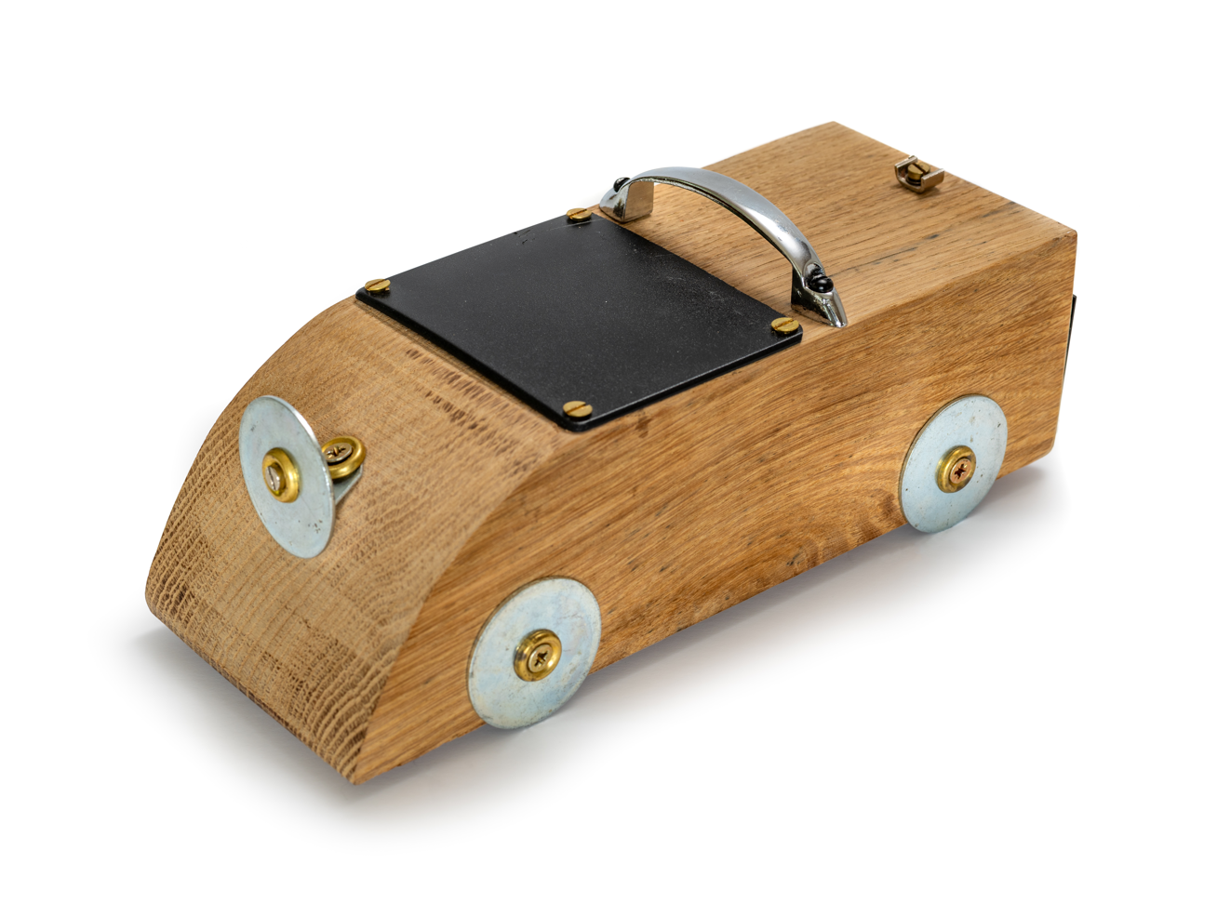
MEDIA INFORMATION
You can find all our press releases and press kits, as well as a wide selection of high-resolution, downloadable photographs and video footage at our media website, PressClub.
You can also follow the marque on social media: LinkedIn; YouTube; Instagram; and Facebook.

ABOUT ROLLS-ROYCE MOTOR CARS
Rolls-Royce Motor Cars is a true luxury house, creating the world’s most recognised, revered and desirable handcrafted Bespoke products for its international clientele.
There are over 2,500 people working at the Home of Rolls-Royce at Goodwood, West Sussex. This comprises both its global headquarters and Centre of Luxury Manufacturing Excellence – the only place in the world where Rolls-Royce motor cars are designed, engineered and meticulously built by hand. An independent study by the London School of Economics & Political Science confirms that since the company first launched at Goodwood in 2003, it has contributed more than £4 billion to the UK economy and adds more than £500 million in economic value every year.
Rolls-Royce Motor Cars is a wholly owned subsidiary of the BMW Group and is a completely separate, unrelated company from Rolls-Royce plc, the manufacturer of aircraft engines and propulsion systems.

CONTACTS | GOODWOOD
Director of Global Communications  Emma Begley: +44 (0)1243 384060 Email | Head of Corporate Relations  Andrew Ball: +44 (0)7815 244064 Email
Head of Global Luxury and Corporate Communications  Marius Tegneby: +44 (0)7815 246106 Email | Head of Global Product Communications  Georgina Cox: +44 (0)7815 370878 Email
Global Bespoke Communications  Malika Abdullaeva:  +49 151 6019 7646 Email | Global Product Communications  Manager  Luke Strudwick: +44 (0)7815 245918 Email
CONTACTS | GLOBAL
The Americas  Gerry Spahn: +1 201 930 8308 Email | Asia Pacific (South) and India  Juliana Tan: +65 9695 3840 Email
Central/Eastern Europe and Central Asia  Frank Tiemann: +49 160 9697 5807 Email | Central and Western Europe  Ruth Hilse: +49 89 382 60064 Email
China  Ou Sun: +86 186 0059 0675 Email | Japan and Korea  Yuki Imamura: +81 90 5216 1957 Email
Middle East and Africa  Haya Shanata: +971 56 171 7883 Email | United Kingdom and Ireland  Isabel Matthews: +44 (0)7815 245127 Email

