ROLLS-ROYCE | MEDIA INFORMATION
ROLLS-ROYCE EXTENSION PROJECT ADDS £3.1 MILLION
TO THE LOCAL ECONOMY IN ITS FIRST YEAR

Tuesday 17 March 2026, Goodwood, West Sussex
- Landmark Rolls-Royce extension project at Goodwood adds £3.1 million to the local economy in first year of build
- Figures set out in new Social, Local, Economic Value (SLEV) report
- Up to 700 people across more than 50 trades working on site each day
- Over 100 local supply chain jobs created
- Project generates more than £500,000 in new business for local hotels in first year
- New building remains on schedule to be fully operational by 2029

“The new extension at the Home of Rolls-Royce at Goodwood is a once-in-a-generation project that will enable us to build ever more extraordinary motor cars for our clients worldwide, safeguarding our business’s future and its immense contribution to the UK economy for decades to come. This new Social, Local, Economic Value report reveals that the presence of up to 700 tradespeople on site has brought new business worth over £3 million in the last year alone, directly into Chichester and the local area; we expect strong levels of local spending to continue for the duration of the build. Throughout the project, we have worked closely with our neighbours, Westhampnett Parish Council and local councillors, and we remain grateful for their continued support.”
Andrew Ball, Head of Corporate Relations, Rolls-Royce Motor Cars

The landmark extension project currently under construction at the Home of Rolls-Royce at Goodwood has already added more than £3 million directly into the local economy, according to research.
The new Social, Local, Economic Value (SLEV) report, compiled by the project’s main contractor, TSL, shows that spending with local businesses involved in the supply chain totalled just over £3.1 million in 2025.
Local hotels have seen new business worth more than £500,000, with some now booked for weeks or even months in advance at a time.
The project has supported the creation of high-value roles, with 115 people recruited by local firms across the supply chain.
The SLEV report is the result of months of meticulous data-gathering and analysis by the project’s main contractor, TSL, which routinely conducts such studies on schemes of this magnitude, complexity and importance. It is the second major examination of Rolls-Royce’s contribution to the local economy, building on the foundational Economic Impact Report produced by the London School of Economics (LSE) in 2023. That study, the first of its kind in the company’s history, demonstrated that Rolls-Royce Motor Cars adds more than £500 million to the UK economy annually, with almost 20% generated locally in Chichester, West Sussex and surrounding areas.
The extension’s new building, which represents a total investment of over £300 million, has reached a significant milestone and is now fully weathertight, with the fit-out of Rolls-Royce’s specialist technologies already underway. Among their most significant tasks is installing a new Surface Finish Centre (paint shop) together with creating dedicated areas for Bespoke and Coachbuild commissions. The extension is on schedule to be fully operational in 2029.

- ENDS -

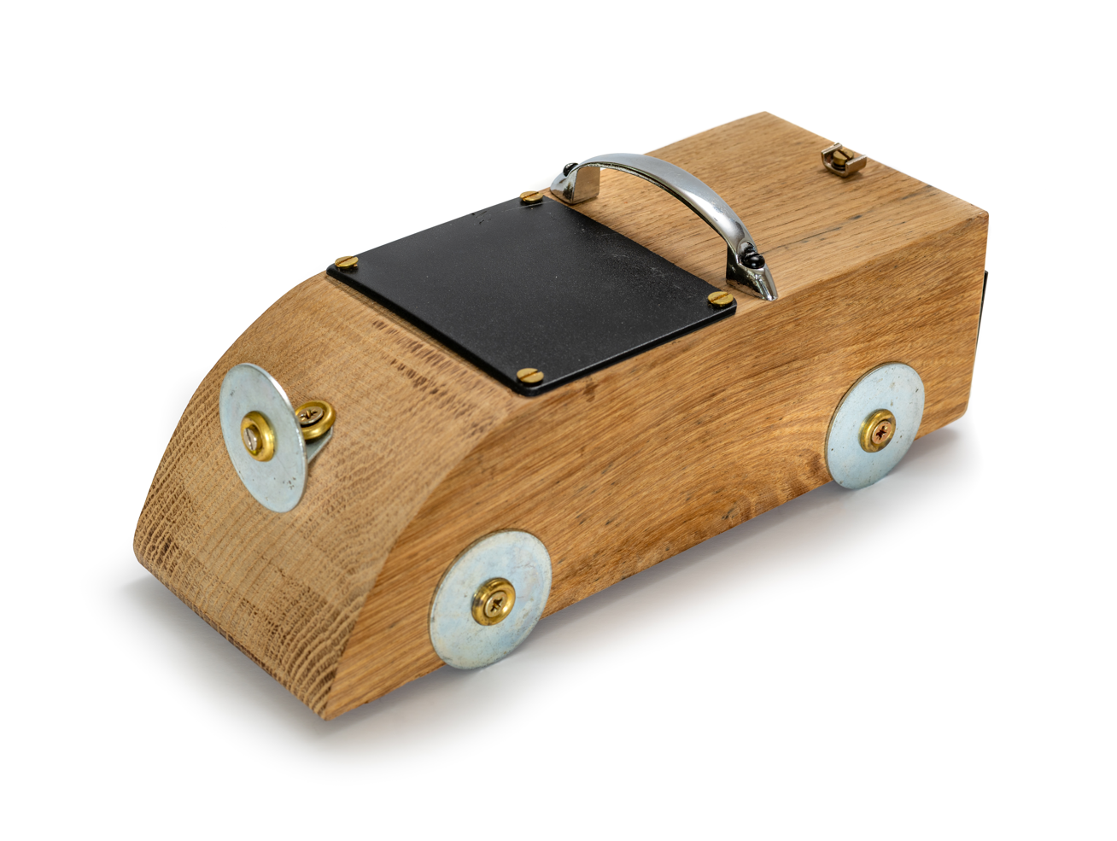
MEDIA INFORMATION
You can find all our press releases and press kits, as well as a wide selection of high-resolution, downloadable photographs and video footage at our media website, PressClub.
You can also follow the marque on social media: LinkedIn; YouTube; Instagram; and Facebook.

ABOUT ROLLS-ROYCE MOTOR CARS
Rolls-Royce Motor Cars is a true luxury house, creating the world’s most recognised, revered and desirable handcrafted Bespoke products for its international clientele.
There are over 2,500 people working at the Home of Rolls-Royce at Goodwood, West Sussex. This comprises both its global headquarters and Centre of Luxury Manufacturing Excellence – the only place in the world where Rolls-Royce motor cars are designed, engineered and meticulously built by hand. An independent study by the London School of Economics & Political Science confirms that since the company first launched at Goodwood in 2003, it has contributed more than £4 billion to the UK economy and adds more than £500 million in economic value every year.
Rolls-Royce Motor Cars is a wholly owned subsidiary of the BMW Group and is a completely separate, unrelated company from Rolls-Royce plc, the manufacturer of aircraft engines and propulsion systems.

CONTACTS | GOODWOOD
Director of Global Communications  Emma Begley: +44 (0)1243 384060 Email | Head of Corporate Relations  Andrew Ball: +44 (0)7815 244064 Email
Head of Global Luxury and Corporate Communications  Marius Tegneby: +44 (0)7815 246106 Email | Head of Global Product Communications  Georgina Cox: +44 (0)7815 370878 Email
Global Bespoke Communications  Malika Abdullaeva:  +49 151 6019 7646 Email | Global Product Communications  Manager  Luke Strudwick: +44 (0)7815 245918 Email
CONTACTS | GLOBAL
The Americas  Gerry Spahn: +1 201 930 8308 Email | Asia Pacific (South) and India  Juliana Tan: +65 9695 3840 Email
Central/Eastern Europe and Central Asia  Frank Tiemann: +49 160 9697 5807 Email | Central and Western Europe  Ruth Hilse: +49 89 382 60064 Email
China  Ou Sun: +86 186 0059 0675 Email | Japan and Korea  Yuki Imamura: +81 90 5216 1957 Email
Middle East and Africa  Haya Shanata: +971 56 171 7883 Email | United Kingdom and Ireland  Isabel Matthews: +44 (0)7815 245127 Email

